ANSI/RESNET/ICC 301-2014 Addendum N-2018
Normative Appendix B

ANSI Approved Date December 6, 2018
Effective Date January 5, 2019
Transition Period End Date July 1, 2019

NORMATIVE APPENDIX B

INSPECTION PROCEDURES FOR MINIMUM RATED FEATURES

Contents
General 4
Foundation/Floor Assembly 5
Wall Assembly 13
Roof/Ceiling Assembly 18
Rim/Band Joists or Floor Perimeters 22
Doors 24
Windows 25
Skylights 27
Passive Solar System 28
Air Leakage 29
Heating and Cooling Distribution System 30
Heating and Cooling Equipment 34
Service Hot Water Equipment 41
Service Hot Water Distribution 45
Solar Domestic Hot Water Equipment 46
Light Fixtures 48
Refrigerator(s) 50
Dishwasher(s) 50
Range/Oven 51
Clothes Washer 51
Clothes Dryer 52
Ceiling Fans 53
Dwelling Unit Mechanical Ventilation System(s) 54
Corridor Ventilation 56
On-Site Power Production 56

General
Rated Feature | Task | On-Site Inspection Protocol
Applies to relevant Minimum Rated Features (MRF) from Table 4.5.2(1) | Record field inspections and performance tests by digital/electronic means  All records shall be kept for a minimum of 3 years | Clearly document the following:  - The date and time of the inspection/test  - The name of the Certified Rater, Approved Inspector, or Approved Tester conducting the inspection/test  - The Dwelling Unit being inspected/tested containing sufficient detail to indicate the location of the inspection, including the address or unit number of the inspected/tested Dwelling Unit  - If included in the Energy Rating and present in the Dwelling Unit, a minimum of one representative photo of items #2 (Wall Assembly); #3 (Roof/Ceiling Assembly); and either #11 (Heating Equipment), #12 (Cooling Equipment), or #14 (Service Hot Water Equipment) from Table 4.5.2(1) that reflect the reported data  - If testing is conducted in the Dwelling Unit, a photo of the recorded test results or a report generated by automated software that communicates with the testing device showing the test result  Each photo and/or report shall be time/date stamped and geotagged.

Building Element: Floor/Foundation Assembly
Rated Feature | Task | On-Site Inspection Protocol
Gross Area and perimeter | Measure floor/foundation dimensions | For floors and slabs, measure dimensions of floor to calculate area. For slab-on-grade, also calculate total perimeter and perimeter exposed to other conditioned spaces.  For conditioned basements and crawlspaces, measure dimensions of walls and floor to calculate area. Divide walls into above and below grade sections.  Dimensions shall be measured and rounded to the nearest ½ foot, and the square footage calculated and rounded to the nearest square foot. Dimensions shall use exterior measurements starting at the exterior finished surface of the outside wall. Openings to the floor below shall not be included in the square footage calculation, except for stairways; stairways and associated landings are counted as square footage on both the starting and ending levels. The “footprint” of protruding chimneys or bay windows shall not be included. The “footprint” of other protrusions like a cantilever when it includes finished floor area shall be included. For Detached Dwelling Units, the square footage of separate finished areas that are connected to the main body of the house by conditioned hallways or stairways shall be included.  Each unique floor exposure, construction type, and R-Value combination shall be calculated separately.
Foundation type | Determine whether foundation is a crawlspace or basement, and if it meets the criteria for Conditioned Space Volume, Unconditioned Space Volume, Unrated Conditioned Space, and/or Infiltration Volume. | Use the definitions in Section 3 to determine whether a crawlspace or basement is Conditioned Space Volume, Unconditioned Space Volume, Unrated Conditioned Space, and/or Infiltration Volume.
Floor type | Identify floor over crawlspace | A crawlspace is a foundation condition with a vertical dimension between the floor joists and ground or slab that is 6 feet or less. Vented crawlspaces have some form of vent or louver in the crawlspace walls or are constructed in a manner such that air moves freely from outside the walls to inside the crawlspace. Unvented crawlspaces are constructed without any form of vents or louvers in the wall and are constructed to exclude air from outside the walls to inside the crawlspace. Unvented crawlspaces may also be Conditioned Space Volume.
 | Identify slab-on-grade floor/foundation | A slab-on-grade is recognized by the absence of either a crawlspace or basement. A slab-on-grade is constructed by pouring a concrete slab directly on the ground as the floor for the Dwelling Unit.  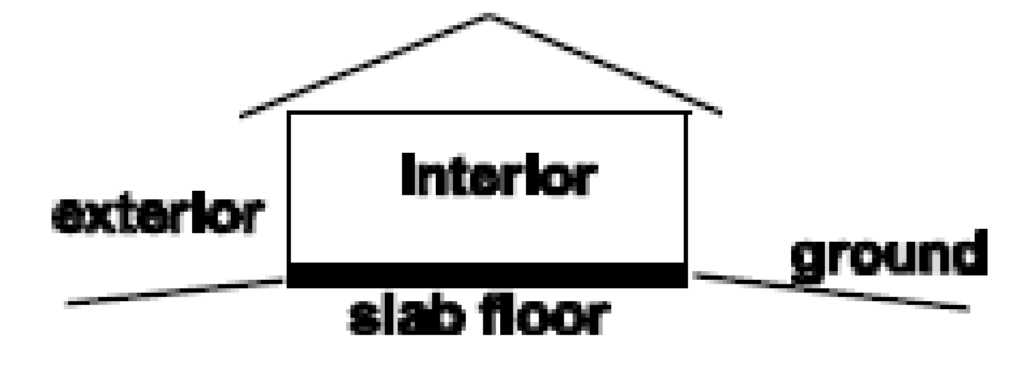
 | Identify floor over full basement | A full basement has characteristics like a crawlspace, except that the clear vertical dimension is greater than 6 feet.
 | Identify walkout basement | A walkout basement is a basement where a portion of the slab floor is on-grade and a portion is below grade.
 | Identify floor over exterior space | A floor that extends horizontally beyond the story below and is exposed to the exterior underneath is considered floor to exterior.  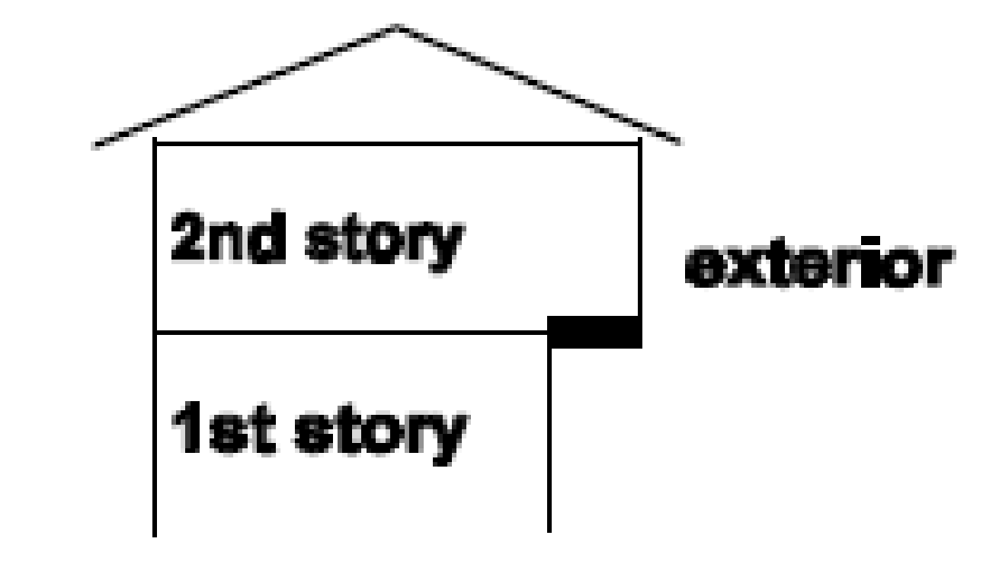
 | Identify floor over garage | Identify floors over a garage.  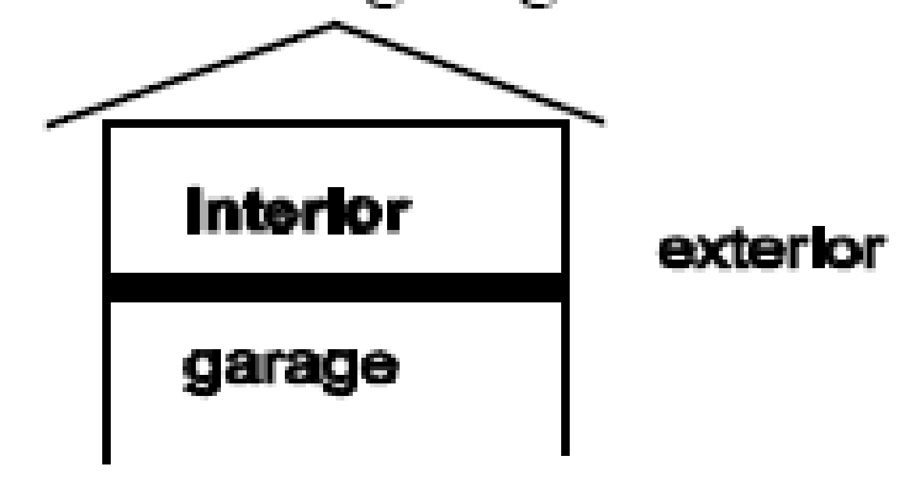
 | Identify floor of Attached Dwelling Unit over garage | Where the floor of an Attached Dwelling Unit is exposed to a garage space beneath it that is not shared with other Dwelling Units, that garage space shall be considered Unconditioned Space Volume. Otherwise, that floor of the Attached Dwelling Unit is facing one of the space types described in the next entry.
 | Identify floor of Attached Dwelling Unit over Multifamily Buffer Boundary, Unrated Conditioned Space, Unrated Heated Space, or Non-Freezing Space | Floor above Multifamily Buffer Boundary – The space directly below the Dwelling Unit has no heating or cooling system or the space is not designed to maintain space conditions at 78 °F (26 °C) ± 5°F for cooling and 68 °F (20 °C) ± 5°F for heating.  Floor above Unrated Conditioned Space – The space directly below the Dwelling Unit is serviced by a heating or cooling system designed to maintain space conditions at 78 °F (26 °C) ± 5°F for cooling and 68 °F (20 °C) ± 5°F for heating.  Floor above Unrated Heated Space – The space directly below the Dwelling Unit is outside of the Conditioned Space Volume, and only interacts with the Rated Home via the shared services located within. This space is not cooled.  Non-Freezing Space – the temperature of the space directly below the Dwelling Unit varies with outside temperature but is heated as necessary to stay at or aboveli40°F.
Framing members | Determine the size of the framing members for all framed floors | Determine the framing member size and spacing for framed floors at each floor exposure.  When framing cannot be directly observed, check the framing by looking for an access through another part of the building or by looking at the rim space from the outside.
Interior surface condition | Determine if the inside surface condition of floor is exposed or covered | Covered - Floors covered with wall-to-wall carpet are considered covered. Floors with only area rugs are not considered covered.  Exposed - Floors covered with tile, linoleum, vinyl, or wood are considered exposed.
Foundation insulation | Determine type, grade, location, and thickness of foundation insulation and resultant R-Value | Use the inspection procedures in Normative Appendix A to determine the type and grade. Visually confirm location as interior or exterior, record R-value, and measure thickness. Visually confirm whether insulation product is installed for 100% of required area/perimeter and visually confirm and record R-value. If insulation is observed without a labeled R-Value, the manufacturer’s data sheet shall be used to determine the R-Value based on installed thickness.  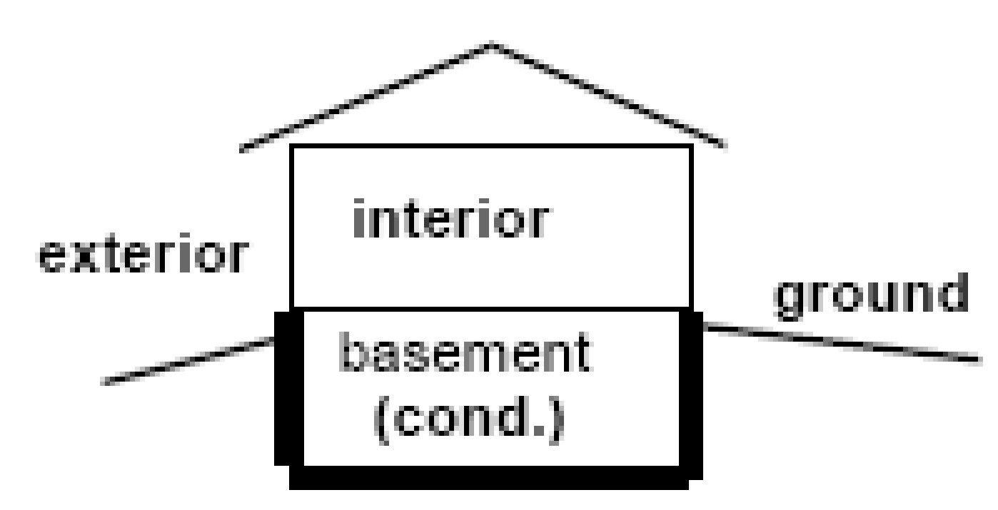  If 100% of the area/perimeter of the foundation insulation cannot be visually confirmed, inspect according to the protocol below:  Visually confirm insulation product is installed for a minimum of 25% of the area/perimeter of the foundation insulation specified for insulation, and visually confirm and record R-value. Where R-Value cannot be determined during site observation, the manufacturer’s data sheet shall be used. Use the inspection procedures in Normative Appendix A to determine the grade of insulation. The grade of the visually confirmed area shall be applied to the rest of the area unless photos show any additional deficiencies, in which case the grade recorded shall be the worst case documented.  Collect photos to confirm installation at several site locations and in sufficient detail to confirm thickness, type, and grade of the insulation installation. If foundation insulation cannot be visually verified immediately after installation, it may be verified through comprehensive photographs that comply with the requirements given above.
Floor insulation | Determine type, grade, and thickness of floor insulation and resultant R-Value | Use the inspection procedures in Normative Appendix A to determine the type and grade of floor insulation. For loose fill applications, multiply the thickness of the insulation in inches by the appropriate R-Value per inch based on the insulation type in order to calculate the total floor insulation R-value.  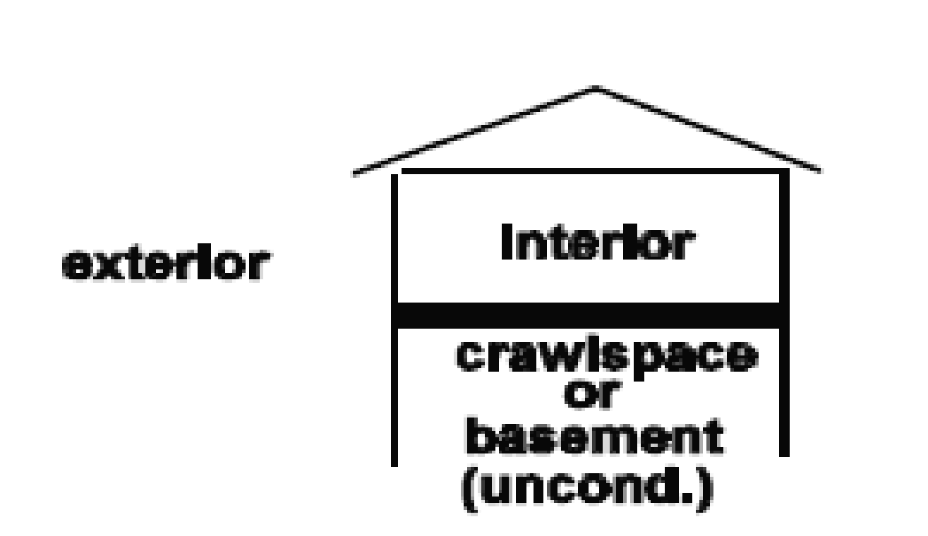
Slab-on-grade insulation | Determine type, grade, location, and thickness of slab-on-grade insulation and resultant R-value | Slab perimeter insulation is installed vertically, either on the outside of the slab extending above and/or below grade or between the foundation wall and the slab itself. Under slab insulation is installed horizontally, either along the slab perimeter or underneath the entire slab.  Use the inspection procedures in Normative Appendix A to determine the type and grade. Visually confirm location as horizontal or vertical, record R-Value, and measure thickness. Visually confirm whether insulation product is installed for 100% of required area/perimeter and visually confirm and record R-Value. If insulation is observed without a labeled R-Value, the manufacturer’s data sheet shall be used to determine the R-Value based on installed thickness.  If 100% of the area/perimeter of the slab insulation cannot be visually confirmed, inspect according to the protocol below:  Visually confirm insulation product is installed for a minimum of 25% of the area/perimeter of the slab specified for insulation and visually confirm and record R-value. If insulation is observed without a labeled R-Value, the manufacturer’s data sheet shall be used to determine the R-Value based on installed thickness. Use the inspection procedures in Normative Appendix A to determine the grade of insulation. The grade of the visually confirmed area shall be applied to the rest of the area unless photos show any additional deficiencies, in which case the grade recorded shall be the worst case documented.  Collect photos to confirm installation at several site locations and in sufficient detail to confirm thickness, type, and grade of the insulation installation.  If slab insulation cannot be visually verified immediately after installation, it may be verified through comprehensive photographs that comply with the requirements given above.

Building Element: Wall Assembly
Rated Feature | Task | On-Site Inspection Protocol
Gross Area | Determine surface area of all walls | Measure linear perimeter of the walls and round to the nearest ½ foot. Measure the interior wall height of the walls and round to the nearest ½ foot. Use these measurements to calculate surface area and round to the nearest square foot.  Each unique wall exposure, construction type, and R-Value combination shall be calculated separately.
Wall exposure | Determine whether walls border exterior, Unconditioned Space Volume, Multifamily Buffer Boundary, Unrated Conditioned Space, Unrated Heated Space, Non-Freezing Space, or adjacent building | Wall to exterior – Walls border exterior space.  Wall to Unconditioned Space Volume – Walls border Unconditioned Space Volume, as defined in Section 3.  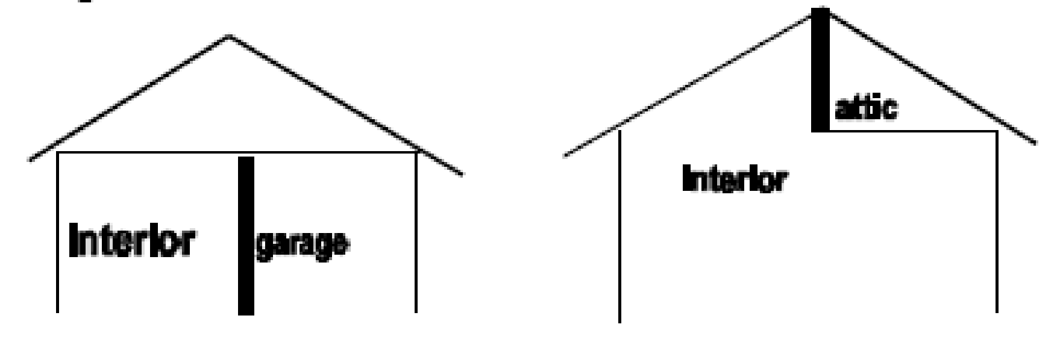  Wall to Multifamily Buffer Boundary – The space adjacent to the Dwelling Unit wall has no heating or cooling system or the space is not designed to maintain space conditions at 78 °F (26 °C) ± 5°F for cooling and 68 °F (20 °C) ± 5°F for heating.  Wall to Unrated Conditioned Space Volume – The space adjacent to the Dwelling Unit wall is serviced by a heating or cooling system designed to maintain space conditions at 78 °F (26 °C) ± 5°F for cooling and 68 °F (20 °C) ± 5°F for heating.  Wall to Unrated Heated Space – The space adjacent to the Dwelling Unit wall is outside of the Conditioned Space Volume, and only interacts with the Rated Home via the shared services located within. This space is not cooled.  Wall to Non-Freezing Space – The temperature of the space directly adjacent to the Dwelling Unit wall varies with outside temperature but is heated as necessary to stay at or above 40°F.  Wall to Adjacent Building – When a Dwelling Unit is directly adjacent to another building, the walls adjacent to that other building shall be considered exterior walls. However, if there is no air space present between the two buildings and the building that is adjacent is inspected and determined to meet the definition of Conditioned Space Volume, then the wall shall be considered adiabatic.
Construction type | Determine the structural system of walls | Wood framing – Wood studs are typically located at 16" or 24" on center along the wall. Measure and record the on-center spacing of the studs.  Metal framing – Steel studs are more common in construction over 5 stories.  Masonry walls – Masonry walls are load-bearing walls constructed of concrete or brick. A wood framed wall with brick veneer is not a masonry wall. Also record the siding or finish material on the exterior of the wall and if interior framing is present, record whether it is wood or metal.  Foam core walls – Foam core walls are a sandwich panel consisting of a foam center with outer layers of structural sheathing, gypsum board, or outer finish materials. Foam core panels may be structural or non-structural. Structural panels are also known as structural insulated panels (SIPs). Non-structural panels are frequently used in post and beam construction.  Log walls – Log walls are solid wood walls, using either milled or rough logs or solid timbers. Some homes have the appearance of solid log walls, yet are actually wood frame walls with siding that looks like solid logs inside and out. Some log walls are manufactured with insulated cores. Assume no added insulation exists in a log wall unless manufacturer's data sheet and/or a visual inspection confirms insulation type and thickness.
Framing members | Determine the size of the framing members for all framed walls | Where framing is visible:  If insulation is in place, carefully probe depth using tape measure, wire probe, or foam insulation depth gauge while disturbing as little of the assembly as possible.  Where framing is not visible:  Measure the width of the window or door jambs;  Subtract the widths of the wall coverings and sheathing materials;  Compare the remaining width to 3.5" for a 2x4 wall or 5.5" for a 2x6 wall;  Where exposed garage walls exist, examine them for reference, although they will not always be the same as other walls;  Where a wall does not come close to the framing width of a 2x4 or 2x6, inspect for continuous insulation on the inside or outside of the walls or look for "double stud" or "strapped" walls or other factors that account for a thickness greater than 5.5". For brick veneer walls, assume 4.5" - 5" for brick, airspace, and sheathing material.  Check the framing member size on all sides of the Dwelling Unit. When an addition has been added, be sure to check the walls of the addition separately. Where the Dwelling Unit has more than one story, check the framing member size for each floor.
Wall insulation installation | Determine type, grade, and thickness of framed wall insulation and resultant R-Value | Use the inspection procedures in Normative Appendix A to verify the insulation type and grade of the insulation installed in the framed wall stud cavity. Visually confirm and record R-Value and measure thickness. If insulation is observed, but the R-Value cannot be determined during site observation, the manufacturer’s data sheet shall be used.
 | Determine type, grade, and thickness of continuous exterior insulation and resultant R-Value | Use the inspection procedures in Normative Appendix A to determine the insulation type and grade. Visually confirm whether insulation product is installed for 100% of area specified for insulation and visually confirm and record R-Value and measure thickness. If insulation is observed without a labeled R-Value, the manufacturer’s data sheet shall be used to determine the R-Value based on installed thickness.  If 100% of the area of the exterior insulation cannot be visually confirmed, inspect according to the protocol below:  Visually confirm insulation product is installed for a minimum of 25% of the area specified for insulation and visually confirm and record R-Value and measure thickness. If insulation is observed without a labeled R-Value, the manufacturer’s data sheet shall be used to determine the R-Value based on installed thickness. Use the inspection procedures in Normative Appendix A to determine the type and grade of insulation. The grade of the visually confirmed area shall be applied to the rest of the area unless photos show any additional deficiencies, in which case the grade recorded shall be the worst case documented.  Photos to confirm installation at several site locations and in sufficient detail to confirm thickness, type, and grade of the insulation installation.  If exterior insulation cannot be visually verified immediately after installation, it may be verified through comprehensive photographs that comply with the requirements given above.
Existing insulation in walls | Determine if wall insulation exists in existing Dwelling Unit | Check at plumbing outlet under sink or, in order of preference, remove cable outlet plate, telephone plate, electrical switch plates and/or electrical outlet plates on exterior walls. Probe the cavity around the exposed plate with a non-metal device. Determine type of insulation. Inspect outlets/switch plates on each side of the Dwelling Unit to verify that all walls are insulated.  Multiply the wall framing member size in inches by the R-Value per inch. Use 3.5" for 2x4 walls and 5.5" for 2x6 walls constructed after 1945.  When an addition has been added, check the walls of the addition separately. Where the Dwelling Unit has one more than one story, check each floor.
Color | Determine the color of the exterior walls | Identify the color of the walls as light, medium, or dark.
Thermal mass | Determine type and thickness of all mass walls | Where the Dwelling Unit's walls are constructed of concrete, masonry, or brick (other than brick veneer), determine their type and thickness.  Solid concrete walls (poured)  Measure the thickness of the poured concrete wall in inches.  Concrete Masonry Unit  Measure the thickness of the wall in inches. Inspect for vermiculite or perlite insulation or other additional insulation.

Building Element: Roof/Ceiling Assembly
Rated Feature | Task | On-Site Inspection Protocol
Gross Area | Obtain measurements of all roof/ceiling areas | Measure the linear perimeter of the ceiling area and round to the nearest ½ foot and use these measurements to calculate surface area of the ceiling and round to the nearest square foot.  When a ceiling area is vaulted, it is necessary to calculate dimensions geometrically.  Each unique roof/ceiling exposure, construction type, and R-Value combination shall be calculated separately.
Ceiling exposure | Determine ceiling exposure | Identify the ceiling as one of the four following types.  1. Ceiling to attic  When the ceiling has attic space above, even when the ceiling is vaulted, as in a scissor truss, it is considered “ceiling to attic.” Compare the vaulted ceiling angle against the angle of the roof. Where the ceiling angle is lower, there is attic space above the ceiling. Also check for an attic access, either separate or from an attic over another part of the building.  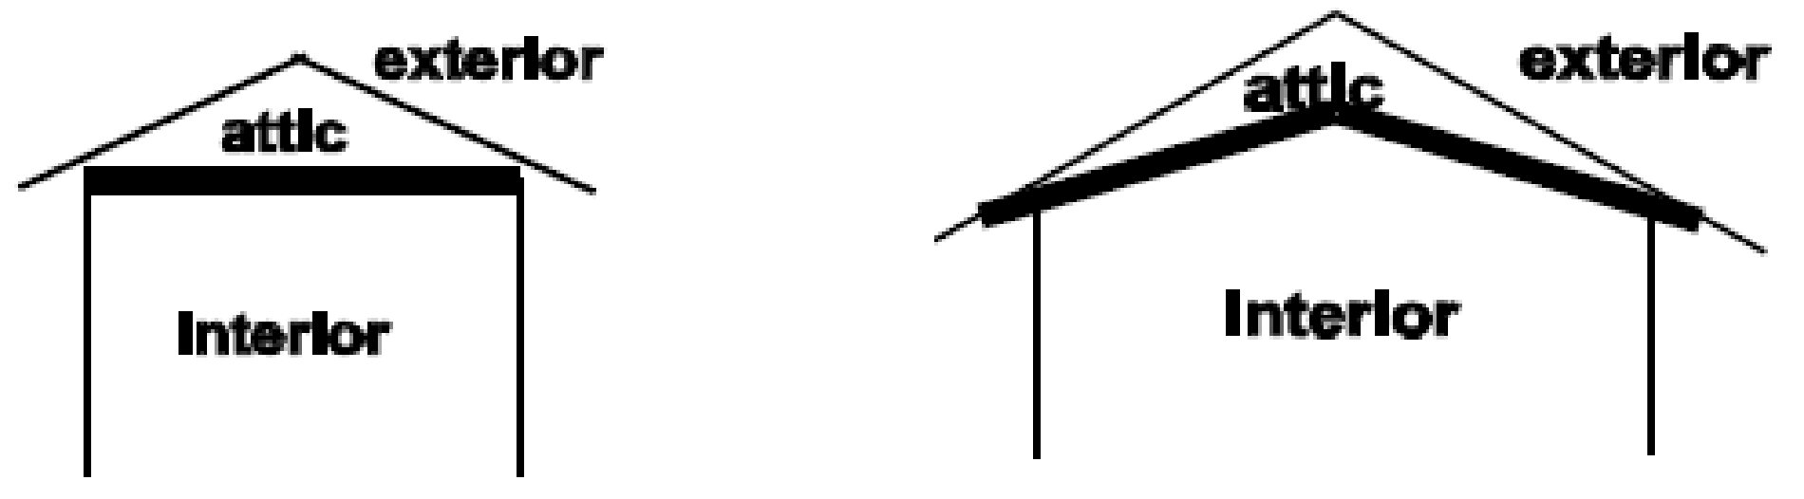  2. Ceiling to exterior  When the ceiling has no attic space above, even when the ceiling is flat, it is considered “ceiling to exterior.”  3. Ceiling to Multifamily Buffer Boundary  When the ceiling of the Attached Dwelling Unit has non-exterior, non-attic space directly above that has no heating or cooling system or the space is not designed to maintain space conditions at 78 °F (26 °C) ± 5°F for cooling and 68 °F (20 °C) ± 5°F for heating, it is considered “ceiling to Multifamily Buffer Boundary.”  4. Ceiling to Unrated Conditioned Space  When the ceiling of the Attached Dwelling Unit has unrated space directly above, which may be another Dwelling Unit or another conditioned space in the building, that is conditioned by a heating or cooling system designed to maintain space conditions at 78 °F (26 °C) ± 5°F for cooling and 68 °F (20 °C) ± 5°F for heating, it is considered “ceiling to Unrated Conditioned Space.”
Construction type | Determine ceiling construction type | Framed ceilings fall into two categories.  Roof on exposed beams or rafters – when you look up from inside the room, you will see exposed beams or rafters.  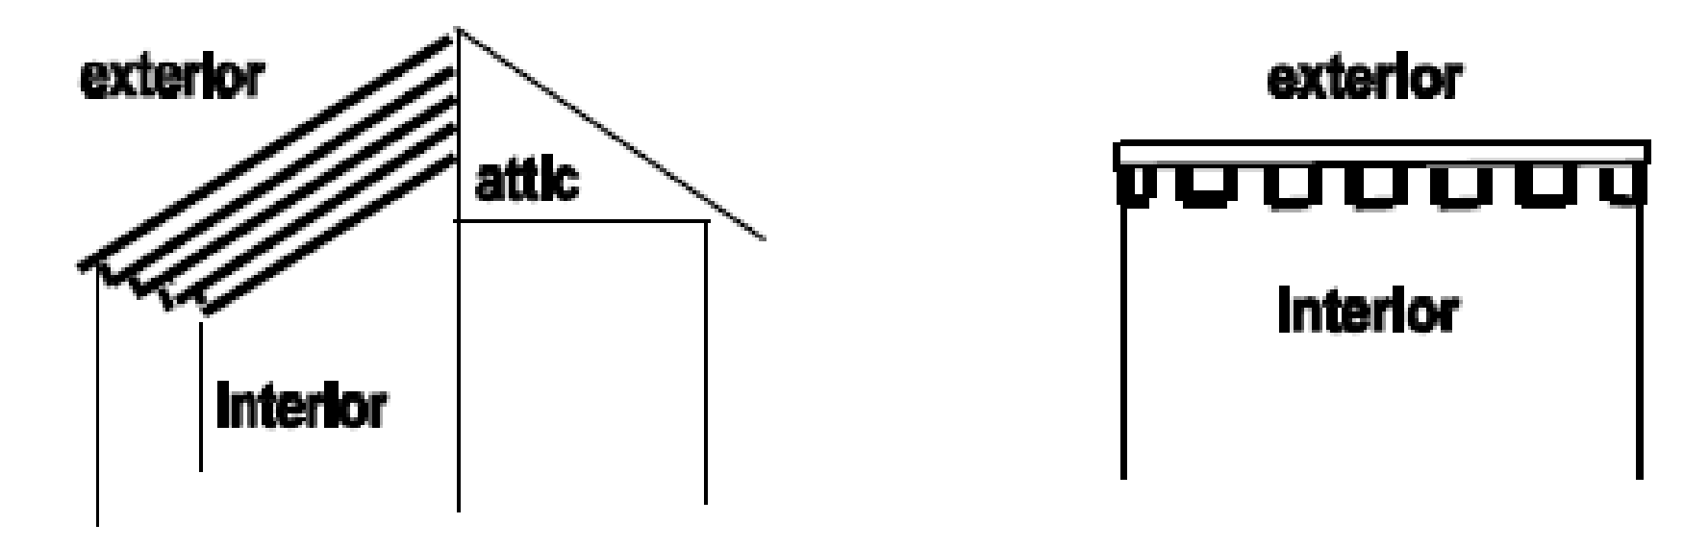  Finished framed ceiling – when a ceiling is framed, but you cannot see the framing because the ceiling is finished with drywall, plaster, or paneling, record it as a finished framed ceiling.
Framing members | Determine the size of the framing members for all framed ceilings | Determine the framing member size and spacing for framed ceilings at each ceiling exposure.  When framing cannot be directly observed, check the framing by looking for an access through an attic over another part of the building or by looking at the rafters from the outside.
Ceiling insulation | Determine type, grade, and thickness of insulation in framed ceiling and/or attic and resultant R-value | Determine the insulation R-Value that exists in the attic/ceiling, unless it is ceiling to Unrated Conditioned Space. Use the following method for calculating the overall ceiling R-value:  - Use the inspection procedures in Normative Appendix A to determine the type and grade of the ceiling insulation present;  - Record when the insulation is a combination of more than one type;  - In the attic, measure the average depth in four places. Record whether the cavity insulation leaves the framing elements exposed, or covers them; when covered, record the thickness that covers the framing;  - Multiply the R-Value of the material by the depth of the insulation.  When there is no access to the attic or framed ceiling, a default R-Value shall be used based on current and historical local building practice and building code.
Roof construction type | Determine roof construction type | Identify the type of roofing surface. Some common types include asphalt shingle, pebble/gravel built-up roof, tile roof, wood shingle roof, rubber roof/roof coating, or metal roof.
Roof color | Determine the color of the roof | Identify the color of the roof as light, medium, or dark. Also check for any reflective roof coating.
Roof deck insulation | Determine type, grade, and thickness of roof deck insulation and resultant R-value | Use the inspection procedures in Normative Appendix A to verify the insulation type and grade. Visually confirm whether insulation product is installed for 100% of required area and visually confirm and record R-Value and measure thickness. If insulation is observed without a labeled R-Value, the manufacturer’s data sheet shall be used to determine the R-Value based on installed thickness.  If 100% of the roof area cannot be visually confirmed, inspect according to the protocol below:  Visually confirm insulation product is installed for a minimum of 25% of the area specified for insulation and visually confirm and record R-Value and measure thickness. If insulation is observed without a labeled R-Value, the manufacturer’s data sheet shall be used to determine the R-Value based on installed thickness. Use the inspection procedures in Normative Appendix A to determine the grade of insulation. The grade of the visually confirmed area shall be applied to the rest of the area unless photos show any additional deficiencies, in which case the grade recorded shall be the worst case documented.  Collect photos to confirm installation at several site locations and in sufficient detail to confirm thickness, type, and grade of the insulation installation.  If roof deck insulation cannot be visually verified immediately after installation, it may be verified through comprehensive photographs that comply with the requirements given above.

Building Element: Rim/Band Joists or Floor Perimeters
Rated Feature | Task | On-Site Inspection Protocol
Rim/band joist insulation installation | Inspect rim/band/floor perimeter insulation of Dwelling Unit during installation | In wood-framed buildings, the rim joist is the band joist around the perimeter of the floor joists over a basement or crawlspace, or between 2 stories of the building. In other taller multistory buildings, these intermediate floor perimeters may be metal-framed or solid concrete.  Use the inspection procedures in Normative Appendix A to determine the insulation type and grade of insulation. Measure the depth of insulation at the rim/band joist and between stories in a multistory building. If insulation is observed without a labeled R-Value, the manufacturer’s data sheet shall be used to determine the R-Value based on installed thickness.
Existing insulation in rim/band joists | Determine if rim/band insulation exists in existing Dwelling Unit | Crawlspace or Basement  From the basement or crawlspace, visually identify and measure the depth of insulation at the rim joist. Use the inspection procedures in Normative Appendix A to determine the grade of insulation.  Between Stories  Look for access to the area from a garage or a utility access trap door. Visually identify and measure insulation where it exists.  If no access is found, insulation is only assumed to exist at the rim joist between stories when:  - Insulation was found at the rim joist at the top of the crawlspace or basement in the same building; and/ or  - Insulation is found in the walls of the same building.  Otherwise, assume no rim joist insulation exists.

Building Element: Doors
Rated Feature | Task | On-Site Inspection Protocol
Area | Determine area of doors | Measure the linear perimeter of the door and round to the nearest inch. Use these measurements to calculate the area of the door(s) and round to the nearest tenth of a square foot.  Each unique door type and R-Value combination shall be calculated separately.
Construction type | Determine construction type of doors | Determine whether the door(s) is fiberglass, metal, or wood by making a close inspection of its texture, inspecting its side view, or lock cut out. Alternatively, confirm by examining the door for a descriptive label or review the product manufacturer’s data sheet.
Insulation | Determine doors insulation value | Determine the door(s) insulation U-factor value and, if applicable, SHGC by examining the door for a descriptive label or review the product manufacturer’s data sheet. Where insulation cannot be determined, default values shall be based on the local building code in effect at the time of construction.
Presence of a door seal | Inspect for the presence of a door seal on the door where the blower door is installed | Identify the door where the blower door is to be setup for the airtightness test. Inspect for the presence of a door seal installed to minimize air leakage between the door and door frame. Document the presence, installation, quality, and condition of the door seal.

Building Element: Windows
Rated Feature | Task | On-Site Inspection Protocol
Area | Determine area of windows | Measure the width and height of the rough opening for the window and round to the nearest inch. Use these measurements to calculate window area, and round to the nearest tenth of a square foot.  For existing homes or where the rough opening cannot be measured, window dimensions shall be measured from the outside edge of the window framing and include the width of the window frame.  Each unique window type and U-value combination shall be calculated separately.
Construction type | Determine window material and Glazing characteristics | Material  Examine each window frame to determine the type of material used. Visually confirm whether the frame is made of metal, wood, or vinyl. Alternatively, confirm by examining the window for a descriptive label or review the product manufacturer’s data sheet.  Where a metal framed dual- or multiple-paned window is installed, determine if a thermal break is present by looking for two separated metal extrusions connected by a rubber spacer. Alternatively, confirm by reviewing the product manufacturer’s data sheet.  Determine and record the window cladding type. Check both the inside and outside, since some windows will have cladding on one side only.  Glazing Type  Determine and record whether the windows are single-paned, double-paned or multiple-paned. Determine and record whether Glazing has a tint or low-e coating.
Orientation | Determine orientation of all windows | Determine orientation of all windows and record orientation to the nearest cardinal/ordinal points. When using a compass while standing in front of a window inside the Dwelling Unit, record orientation while facing the exterior and adjust for magnetic deviation. When using a compass while standing outside the Dwelling Unit, record orientation while standing with back to the window and adjust for magnetic deviation.
Shading | Determine permanent, fixed shading of windows | Identify permanent, fixed shading devices attached to the building.  Fins and overhangs shall be considered fixed shading devices. Window screens, security bars, balcony railings, movable awnings, roller shades, and shade from adjacent buildings, trees and shrubs shall not be considered fixed shading devices.  Projections and Overhangs  The shading impact of a projection or overhang is found by measuring the length of the overhang from the exterior wall surface, the distance between the top of the window and the bottom edge of the overhang, and the distance between the bottom of the window and the bottom edge of the overhang.  Measure the length of the overhangs over each exterior wall, to the nearest inch.  Measure the distance between both the top of the window and the bottom of the window to the bottom edge of the overhang, to the nearest inch.
Solar heat gain coefficient | Determine solar heat gain coefficient of Glazing | Look for an NFRC label on new windows; it will display SHGC. Where no label is found, identify window in NFRC Certified Products Directory to determine SHGC or consult manufacturer's data sheet. If no SHGC is identified from window label, product literature, or NFRC directory, use the known window characteristics to select the SHGC from Table 10 in the ASHRAE Handbook of Fundamentals.
U-value | Determine window U-value | Look for an NFRC label on new window; it will display full window U-value. Where no label is found, identify window in NFRC Certified Products Directory to determine U-value or consult manufacturer's data sheet. If no U-value is identified from window label, product literature, or NFRC directory, use the known window characteristics to select the U-value from Table 4 in ASHRAE Handbook of Fundamentals.
Natural Ventilation | Determine whether or not there are operable windows in the Dwelling Unit | Inspect all windows located in the Dwelling Unit and document which are operable and which are not.

Building Element: Skylights
Rated Feature | Task | On-Site Inspection Protocol
Area | Determine area of skylights | See windows.
Construction type | Determine framing and Glazing characteristics of skylights | See windows.
Orientation | Determine orientation of skylights | Determine the orientation of the lower edge of the skylight. Use this direction as the orientation of the skylight.
Shading | Determine shading of skylights | See windows.
Solar heat gain coefficient | Determine solar heat gain coefficient of skylights | See windows.
U-value | Determine skylight U-value | See windows.
Tilt | Determine tilt of skylights | Measure the tilt of the skylight relative to horizontal. This may be done with a level and angle finder instrument, or geometrically with a protractor.  If the pitch of the roof is known or can be measured, and if the skylight is in line with the roof, then the roof pitch may also be considered the tilt of the skylights.

Building Element: Passive Solar System
Rated Feature | Task | On-Site Inspection Protocol
Direct gain | Identify system type and determine solar aperture orientation and aperture area | Through proper sizing, placement, orientation, and/or control of windows, skylights, shading devices, and solar storage mass within the building, a solar direct gain system is designed to reduce heating, cooling, and lighting energy requirements.  To determine aperture area, measure width and height of south-facing Glazing and indicate tilt angle. Record glass type(s) and presence of night insulation, when present.  Determine orientation to the nearest cardinal/ordinal point.  Determine the type of thermal mass, its thickness, and its dimensions. Determine whether the mass will be lit by direct solar rays between the hours of 9:00 a.m. and 3:00 p.m. during the winter. Record any trees or other obstructions to solar gain.
Greenhouse or solarium | Identify system type and determine solar aperture orientation, aperture area, and information about thermal mass | A greenhouse or solarium creates a South-glazed buffer zone between the Dwelling Unit and the exterior to help heat the living area.  See Direct gain, above, for specific inspection items.
Thermal storage mass | Identify system type and determine solar aperture orientation, aperture area, and information about thermal mass | Thermal mass systems consist of solar-exposed heavyweight materials with high heat capacitance and relatively high conductance or high thermal diffusivity, that are placed in the same zones(s) as the solar collection area(s). Determine and record whether these elements are integral with the building or distinct elements within the building.  Distinct components:  Trombe wall - uses a heat storage mass placed between the glass and the space to be heated. Measure area of storage mass, determine material, thickness, and capacitance.  Water wall - replaces the existing wall, or parts of it, with containers that hold water.
Thermosiphon Air Panel (TAP) | Identify system type | Thermosiphon air panel (TAP) - has one or more Glazing layers made of glass or plastic, an air space, an absorber, another air space, and (often) an insulated backing. These are similar in appearance to active flat-plate collectors, often mounted vertically on walls, or ground-mounted, so that the living space is higher than the collector to facilitate convection from the TAP to the building.  See Greenhouse, above, for specific inspection items.

Building Element: Air Leakage
Rated Feature | Task | On-Site Inspection Protocol
Blower door test | Determine airtightness from a blower door test | Follow Procedure for Measuring Airtightness of Building or Dwelling Unit Enclosure in ANSI 380.
Infiltration Volume | Determine Infiltration Volume of Rated Home | Determine the Infiltration Volume by adding the Conditioned Space Volume and Unconditioned Space Volume in the Dwelling Unit, in accordance with the definitions.
Compartmentalization Boundary | Determine Compartmentalization Boundary | Determine the Compartmentalization Boundary by calculating the surface area that bounds the Infiltration Volume.

Building Element: Heating and Cooling Distribution System
Rated Feature | Task | On-Site Inspection Protocol
System type | Identify type of distribution system used to provide space heating and cooling | Forced air - a fan unit or air handler connected to ducts that supply heated or cooled air to multiple rooms in the Dwelling Unit. Forced air systems have supply and/or return ductwork.  Unit heater/air conditioner - heating or cooling is supplied directly from a heating or cooling device located within the space it serves. Unitary equipment² has no supply or return ductwork.  Forced hot water - heated water is pumped through a series of radiator elements to supply heat. Identify and record the radiator elements as conventional radiators, baseboard "fin tube" radiators, cast iron baseboards, or radiant hot water panels located at the baseboards or on walls or ceilings.  Hot water radiant system - heated water is circulated through plastic or metal tubing that is installed in a concrete slab or finished floor or, occasionally, in walls or ceilings.  Steam heating - steam systems utilize a distribution system with cast iron radiators connected to a boiler that creates steam. The steam rises into the radiators through one set of pipes, condenses into water, and drains back to the boiler. There are 2 common system types:  One Pipe Steam - radiators have only one pipe connected with a shut off valve. There will also be an air vent on the opposite end of the radiator from the pipe connection.  Two Pipe Steam - radiators will have a larger steam supply pipe and a smaller condensate return pipe. There will be a control valve on the steam side and a steam trap on the condensate side.  Electric radiant system - electric cables are installed in concrete floor slabs or in the ceiling. Electric current is passed through the cables, causing them to heat up, heating the floor, individual radiant wall panels, or the ceiling assembly, which radiates heat to the space.  Baseboard electric resistance - electric elements are installed in baseboard enclosures. Electric current is passed through the electric element to provide heat to the space.  Electric unit heaters - electric elements are enclosed in a cabinet with a blower that is suspended from the ceiling or mounted in a ceiling cavity, wall cavity, under a kitchen or bath cabinet (kickplate) or other areas. In multifamily buildings, look for these units in stairwells, storage rooms, mechanical rooms, water meter closets or any space with a small or low heating load.
Location of air ducts | Determine the location of ducts | Locate and differentiate between supply and return ducts. The location of air ducts shall be recorded as in attic space, crawlspace, basement, or other conditioned or unconditioned space. Use the definitions in Section 3 to classify the locations as Infiltration Volume, Conditioned Space Volume, Unconditioned Space Volume, or Unrated Conditioned Space. Approximate the percentage of both the supply and return ductwork in each area when supply/return ducts are located in more than one area.
Insulation | Determine the R-Value of distribution system insulation | Inspect the ducts or pipes to confirm they are insulated and look for labeling printed on the insulation by the manufacturer. Record R-value. Where insulation is not marked with the R-value, identify type and measure the thickness of the insulation to determine R-value.
Leakage of air ducts | Determine air leakage from ducts | Follow Procedure for Measuring Airtightness of Duct Systems in ANSI 380. The air handler shall be installed prior to testing.
Circulation pumps | Determine the energy use of the distribution pumps | Record the horsepower and model number of any primary and secondary pumps associated with the distribution circulation loop, excluding any pumps on standby. Use the model number of the pumps to determine the pump motor efficiency from the manufacturer’s data sheet. The number of Dwelling Units served by the circulation loop shall also be determined.

Building Element: Heating and Cooling Equipment
Rated Feature | Task | On-Site Inspection Protocol
Equipment class | Identify Class of equipment for heating and/or cooling | Individual - standalone equipment serving a single Dwelling Unit, often located within the Dwelling Unit. These units heat and/or cool the space and, other than electric connections to power the fans, controls, or compressors, are not connected to circulating fluids from a central boiler or Chiller.  Terminal - individual equipment that heats and/or cool the space and are connected to boilers, Chillers, Variable Refrigerant Flow Multi-Split Air Conditioning and Heat Pump Equipment, and/or Cooling Towers. Fan coils and Water Loop Heat Pumps often indicate the use of a remote central boiler and/or Chiller. However, some terminal equipment appears similar to individual equipment and yet relies on a remote energy source to function. Look for insulated water pipes, refrigerant tubing, or control valves and confirm that there is no in-unit heating or cooling equipment or equipment in adjacent spaces that solely serves the terminal equipment of the Dwelling Unit that may be outside of the Dwelling Unit.  Central - larger heating or cooling equipment that serves more than one Dwelling Unit, and possibly common spaces, using a conveyance to deliver and receive a circulating energy transfer medium to heat and/or cool the Dwelling Units through their terminal equipment. The circulation conveyance may be water piping or refrigerant tubing and likely will be insulated. Water loops will have circulating pumps. See Central Equipment below for details.
Location | Determine the location of heating and cooling equipment | Record whether individual, terminal, and central systems are in Conditioned Space Volume, Unrated Conditioned Space, Unrated Heated Space, or Unconditioned Space Volume.
Control system | Identify the control system for the heating and cooling system(s) | Determine the type of control systems and look for separate controls for the heating and cooling systems.  Determine and record whether the Dwelling Unit thermostat controls are programmable, understanding that not all digital thermostats are programmable.
Efficiency | Determine the heating and cooling equipment efficiency and capacity | Look for the equipment nameplates and product literature. Record the manufacturer and model number, capacity, and, if listed directly on the nameplate, the efficiency rating. If not listed, use the model number to identify the efficiency rating in the AHRI directory. Where the nameplate information is not available or not accessible, use manufacturer’s data sheet, equipment directories, or age-based defaults from Section 4.5.2 to determine and record an appropriate efficiency.  SEER is used to measure the cooling efficiency of central air conditioning and Air Source Heat Pump systems. EER is used to determine the cooling efficiency of room air conditioners, VRF, Water Loop Heat Pumps, and Ground Source Heat Pumps. EER can be calculated from the nameplate information by dividing Btu output by Watt input. Chillers are rated in kW/ton.  HSPF or COP is used to measure the heating efficiency of Air Source Heat Pumps, VRF, Water Loop Heat Pumps, and Ground Source Heat Pumps. AFUE or Thermal Efficiency is used to measure the efficiency of furnaces and boilers.
Heating and cooling energy source | Determine fuels used for heating and cooling | Heating systems use natural gas, propane, oil, electricity, or some other fuel. Most cooling systems are driven by electricity, however some cooling equipment uses natural gas or propane.

Building Element: Heating and Cooling Equipment
Rated Feature | Task | On-Site Inspection Protocol
Individual Heating and Cooling Equipment | Identify type(s) of individual equipment for heating and/or cooling of a single Dwelling Unit | Determine the individual heating/cooling type that is present in each Dwelling Unit. Typical unit types are defined below:  Boiler – this device creates hot water or steam, powered by any fuel type, and can be used with forced air distribution, in conjunction with a fan coil unit or PTAC where the fan blows air over the hot water coil to provide heating, or distributed by forced hot water, steam, or a hot water radiant slab system.  Direct evaporative cooler - is used primarily in very dry climates. Evaporative coolers work by blowing air over a damp pad or by spraying a fine mist of water into the air. Direct evaporative coolers add moisture to the home.  Furnace - comprised of a combustion chamber and heat exchanger or an electric resistance element and a fan that forces air across the heat exchanger or resistance element to provide heat in a forced air system.  Ground Source Heat Pumps - are coupled to the ground through the use of a water well. In Attached Dwelling Units, confirm and record when a circulation loop is shared amongst multiple Dwelling Units. See Central Equipment below for details.  Packaged terminal air conditioner (PTAC) - a factory-selected wall sleeve and separate un-encased combination of heating and cooling components, assemblies, or sections. It may include heating capability by hot water, steam, or electricity and is intended for mounting through the wall to serve a single room or zone. If a hot water coil is present, determine if the boiler is individual or central.  Packaged terminal Heat Pump (PTHP) - a PTAC capable of using the refrigerating system in a reverse cycle or Heat Pump mode to provide heat.  Split system Air Source Heat Pump - move energy from one location to another using the vapor compression cycle. They are electrically driven and provide heating in winter and cooling in summer by reversing the direction of heat flow. Split system Heat Pumps consist of an outdoor unit and an indoor air handling unit, resembling a furnace. These systems require ductwork for air distribution. Most Air Source Heat Pumps incorporate electric resistance supplemental heat in the indoor section. However, some Heat Pump systems use a fossil fuel furnace for supplemental heating. These are known as "dual fuel" or add-on systems.  Split system air conditioner - similar to a split system Air Source Heat Pump. Consists of an outdoor unit and a coil in the forced air distribution system. These systems are electrically powered and provide cooling.  Through-the-wall ductless Air Source Heat Pump - a single packaged Air Source Heat Pump installed without a distribution system. Provides both heating and cooling and is installed through an exterior wall.  Unitary space heater - these are fossil fuel burning heaters that have individual controls and no distribution system. Determine and record when the system is equipped with a fan for forcing air circulation over a heat exchanger or uses simple convective forces. These heaters are mounted on outside walls to facilitate venting and use natural gas, kerosene, propane, or other types of fossil fuel.  Variable-speed Mini-Split and Multi-Split Heat Pumps - these systems are listed under “residential” in the AHRI Directory and have multiple configurations, depending on whether the system is “single-port” or “multi-port” and whether it is ducted, non-ducted, or a mix. They are considered individual systems when they serve only one Dwelling Unit³.  Window/through-the-wall air conditioner – is a single packaged ductless air conditioner designed to be installed without a distribution system and without a factory-selected sleeve.  Electric resistance heater – these are electric heaters that typically have individual controls and no distribution system. They are typically either electric baseboard heaters, electric wall heaters, or electric bathroom heaters.

Building Element: Heating and Cooling Equipment
Rated Feature | Task | On-Site Inspection Protocol
Terminal Heating and Cooling Equipment | Identify type(s) of terminal equipment served by centralized systems for heating and/or cooling in each Dwelling Unit | Determine the terminal heating/cooling type that is present in each Dwelling Unit. Typical terminal unit types are defined below:  Fan coil unit – hot/chilled water from a central boiler/Chiller is circulated through a coil. A fan blows air over the coil to provide heating/cooling.  Hot Water Packaged Terminal Air Conditioner (HW PTAC) – a PTAC that includes a hot water coil connected to a central boiler.  Hydronic/radiant or convectors – hot water from a central boiler is pumped through a series of radiator elements to supply heat. Conventional radiator elements are radiators, baseboard “fin tube” radiators, cast iron baseboards, or radiant hot water panels located at the baseboards or on the walls or ceilings.  Variable Refrigerant Flow Multi-Split Air Conditioning and Heat Pump terminal units – refrigerant flows at a variable rate from one or more central outdoor condensing units to evaporator units located in the Dwelling Units. Styles of VRF terminal units include wall mounted, ceiling cassette, ceiling suspended, and are either ducted, non-ducted, or mixed.  Water Loop Heat Pumps – hot/cold water from a centralized boiler and Cooling Tower is circulated through a Heat Pump in each Dwelling Unit.

Building Element: Heating and Cooling Equipment
Rated Feature | Task | On-Site Inspection Protocol
Central Heating and Cooling Equipment | Identify type(s) of central equipment serving terminal units in each Dwelling Unit | Absorption cooler – this is a gas air conditioner. Look for a Cooling Tower, an exhaust pipe, a gas burner to evaporate refrigerant, and a heat exchanger similar to an electric air conditioner.  Boiler – this device creates hot water or steam, may be powered by any fuel type, and can be used with forced air distribution, in conjunction with a fan coil unit or PTAC where the fan blows air over the hot water coil to provide heating, or distributed by forced hot water, steam, or a hot water radiant slab system. Record whether the boiler also provides service hot water.  Chiller – Vapor compression cooling equipment that uses the outdoor air or water circulated through a Cooling Tower as a heat sink for cooling and absorbs heat from conditioned space by means of a hydronic cold water distribution system. Determine whether the Chiller is a DX Chiller, water-cooled, or absorption.  Cooling Tower – A heat rejection device that rejects heat to the atmosphere. Record the fan horsepower from the nameplate data of the Cooling Tower fan located inside the Cooling Tower. Record the horsepower and model number of the sprayer pump located inside the Cooling Tower. Alternatively, record the model number from the nameplate data of the Cooling Tower to determine the fan and sprayer pump data from manufacturer’s data sheet.  Ground Source Heat Pump – shared vapor compression heating and cooling equipment that uses the ground or ground water as the heat source or sink for heat.  Rooftop Make-Up Air Unit (MAU) or Dedicated Outdoor Air System (DOAS) – large rooftop equipment that provides outdoor air or make-up air, with or without heating or cooling. In multifamily buildings, these systems may provide ducted air directly to the Dwelling Units or to other common spaces.  Single packaged air conditioner - similar to single packaged Air Source Heat Pumps, these systems provide cooling only. In multifamily buildings, these systems may provide ducted air directly to the Dwelling Units or to other common spaces.  Single package Air Source Heat Pump - a single package Heat Pump is similar to a split system, except it combines the functions of the indoor and outdoor units into one cabinet, mounted on the roof or on the ground. In multifamily buildings, these systems may provide ducted air directly to the Dwelling Units or to other common spaces.  Variable Refrigerant Flow Multi-Split Air Conditioning and Heat Pump outdoor units – refrigerant flows at a variable rate from one or more central outdoor condensing units to evaporator units located in the Dwelling Units.

Building Element: Service Hot Water (SHW) Equipment
Rated Feature | Task | On-Site Inspection Protocol
Equipment class | Identify class of equipment for Service Hot Water (SHW) | Individual - standalone service hot water system serving a single Dwelling Unit.  Central - shared service hot water system serving more than one Dwelling Unit. These shared systems may also provide service hot water to common spaces and shared laundry rooms.  Laundry - service hot water system providing hot water for shared clothes washers that does not provide other service hot water to the Dwelling Unit.
Location | Determine location of service hot water equipment | Determine whether the water heater is in Conditioned or Unconditioned Space Volume, Unrated Heated Space, or Unrated Conditioned Space.
Efficiency | Determine the Energy Factor, Uniform Energy Factor, or thermal efficiency of the service hot water equipment | Look for the water heater's nameplate and product literature. Record the manufacturer, model number, and if listed directly on the nameplate, the efficiency rating.  Search for the model number in an appropriate efficiency rating directory to determine and record the EF, UEF, or thermal efficiency rating. When thermal efficiency is recorded, also record the standby loss if available.  When the efficiency rating cannot be determined, approximate the age of the unit and use a default efficiency.
Extra tank insulation value | Determine the insulation value of any exterior wrap | Visually determine whether the water heater is or is not wrapped with exterior insulation. When insulation is present, measure the thickness of the wrap and determine and record the R-Value.
Individual service hot water equipment type | Determine type, capacity, and fuel source of standalone water heater serving single Dwelling Unit | Identify whether the equipment is storage or instantaneous, identify its fuel source, and record storage tank capacity in gallons. Also record whether the SHW equipment is supplemented by a desuperheater and/or if it is integrated with the space heating system.  .
Central service hot water equipment type | Determine type, capacity, fuel source, and pump power of shared service hot water equipment serving more than one Dwelling Unit | Identify if equipment is a boiler or water heater, residential or commercial grade, its fuel source, pump power, and record storage tank capacity in gallons. Also record whether the SHW equipment is integrated with the space heating system and how many Dwelling Units it serves.  Central boiler with indirect fired storage tanks – Record the number of boilers and tanks. Record the fuel source and the model number, capacity, and insulation value, when present, of the unfired storage tanks.  Central service hot water heater – Record the number of water heaters, the fuel source, capacity, and insulation value, when present.  Central pump power - in addition, record the horsepower and model number of all primary and secondary pumps that are associated with the service hot water distribution loop, excluding any pumps on standby. If not listed on the nameplate, use the pump model number to determine the pump motor efficiency from the manufacturer’s data sheet.
Laundry service hot water equipment type | Determine type, capacity, and fuel source of laundry SHW equipment | Where a separate service hot water system provides hot water to clothes washers, but does not provide other service hot water to the Dwelling Unit, follow guidance for individual service hot water systems above to identify system type, capacity, and fuel source.
Drain Water Heat Recovery (DWHR) | Determine efficiency and performance factors | Where DWHR units are installed and serve the Rated Home, record the model number of the DWHR unit, its efficiency, and the number of showers in the Rated Home that are connected to the unit.  A performance factor shall be determined based on its installation location. Determine if the DWHR unit supplies pre-heated water to the cold water piping, hot water heater potable supply piping, or to both.

Building Element: Service Hot Water Distribution
Rated Feature | Task | On-Site Inspection Protocol
Hot water pipe length | Determine hot water distribution pipe length | The hot water distribution pipe length from the water heater to the farthest hot water fixture shall be measured horizontally and vertically along its length, assuming the hot water piping does not run diagonally.  For Dwelling Units being served by a Central SHW with a recirculation loop, begin the pipe length measurement from the shared recirculation loop rather than the water heater.  The measured pipe length shall be inspected during construction and re-calculated if it did not conform to the designed plan layout.
Pipe insulation | Determine R-Value of pipe insulation | Inspect the hot water piping for the presence of insulation and record the percentage of piping that is insulated. Measure the thickness of the insulation and identify material to determine its R-Value.
Recirculation system | Determine the hot water recirculation type, control strategy, and branch length | Inspect the hot water distribution system to determine whether the system is a standard system or a recirculation system. A standard system shall be used for Attached Dwelling Units unless the recirculation system is entirely within the Rated Home.  When a recirculation system is entirely within the Rated Home, then the control strategy shall be documented as one of the following strategies.  Uncontrolled – the pump runs continuously  Timer– the pump is controlled by a timer  Temperature control – the pump runs based on monitoring temperature at some point in the system  Demand (presence sensor) – the pump only runs when a sensor detects someone is present at the faucet  Demand (manual) – the pump only runs when a user presses a button indicating they are about to use hot water  The branch hot water pipe length from the recirculation loop to the farthest hot water fixture from the recirculation loop shall be measured longitudinally, assuming the branch hot water piping does not run diagonally.
Flow rates of  faucets and showerheads | Determine gpm of faucets and showerheads | Record the rated gpm printed on all showerheads and faucets. When the gpm rate is not visible, collect documentation showing the model number of the plumbing fixtures and use manufacturer’s data sheet to determine and record the rated gpm.

Building element: Solar Domestic Hot Water Equipment
Rated Feature | Task | On-Site Inspection Protocol
System type | Determine type of solar systems | Determine whether a solar domestic hot water system exists. These systems collect and store solar thermal energy for domestic water heating applications. When a solar water heating system exists, determine system type. For systems manufactured after January 1, 1995, system type, Energy Factor (EF), and other performance characteristics shall be determined from the SRCC label and by referring to SRCC literature. For systems lacking an SRCC label, Energy Factor and other performance characteristics are determined using a certified energy modeling tool or appropriate default values. Identify as passive or active. Base your evaluation on these criteria:  Passive - No purchased electrical energy is required for recirculating water through a passive solar collector. Three types of passive systems are integrated collector storage (ICS), thermosiphon systems and self-pumped systems.  Integrated Collector Storage (ICS) - consists of a single unit that incorporates both collector and water storage⁴.  Thermosiphon - consists of a flat-plate solar collector and hot water storage tank. Instead of using a pump, circulation of the fluid is achieved by natural convection action. The storage tank must be located above the collector, and can be inside or outside the Conditioned Space Volume.  Self-pumped - circulates fluid from storage to collectors without purchased electrical energy. Photovoltaic and percolating systems are self-pumped systems. The storage tank can be inside or outside the Conditioned Space Volume.  Active -Also known as pumped systems.  Pumped -purchased electrical energy input is required for operation of pumps or other components. The storage tank can be inside or outside the Conditioned Space Volume.
Solar collector type | Identify type of solar collector | Identify the type of solar collector by checking for the SRCC label or manufacturer’s data sheet.
Collector details | Determine area, orientation, and tilt of collector | Determine the area of the collector.  Determine the orientation of the solar collector to the nearest cardinal/ordinal point in the direction toward which the collector faces.  To determine the tilt of the collector use either geometric calculations based on horizontal length and vertical height measurements or a site selection and angle finder instrument.
Efficiency | Determine efficiency of solar system | Search for SRCC label. Check for SRCC system and component nameplates. Refer to the Directory of SRCC Certified Solar Collector and Water Heating System Ratings, or other SRCC literature for Energy Factor (EF) and other performance data.
Storage tank size and location | Determine the capacity of the storage tank and location | To determine the size of the storage tank, refer to documentation or a label indicating the tank capacity.  Determine and record whether the storage tank is in Conditioned or Unconditioned Space Volume, Unrated Heated Space, or Unrated Conditioned Space.
Extra tank insulation value | Determine the insulation value of any exterior wrap | See Service Hot Water, above.
Pipe insulation value | Determine the insulation value of the pipes | Determine the R-Value of insulation installed on pipes.

Building Element: Light Fixtures
Rated Feature | Task | On-Site Inspection Protocol
Number of Qualifying and non-qualifying Light Fixtures | Calculate percentage of Qualifying Light Fixtures by dividing the part by the whole | For each of the three categories of lighting locations (ie. Interior, Exterior, and Garage), record whether the Qualifying Light Fixtures are or are not installed at the time of the inspection.  If the Qualifying Light Fixtures are installed at the time inspection, then determine if they are Tier I or Tier II.  For each of the three categories of lighting locations (i.e. Interior, Exterior, and Garage), record the ratio of Qualifying Tier I Light Fixtures to all light fixtures in Qualifying Light Fixture Locations and the ratio of Qualifying Tier II Light Fixtures to all light fixtures in Qualifying Light Fixture Locations. This ratio is calculated by fixture and not by light bulb.

Building Element: Refrigerator(s)
Rated Feature | Task | On-Site Inspection Protocol
Total annual consumption of refrigerator | Determine total annual consumption of refrigerator | Record whether the refrigerator is or is not installed at the time of the inspection.  If the refrigerator is installed at the time of inspection, then record the model number of the refrigerator and determine the total annual consumption from either the refrigerator Energy Guide Label, the California Energy Commission Appliance Database, the age-based defaults from Table 4.2.2.5.2.5(1) of ANSI 301, the EPA ENERGY STAR website, or another reputable source.  Record the location of the refrigerator, whether it is in the Conditioned Space Volume of the Dwelling Unit, Unrated Heated Space, or Unrated Conditioned Space.  If there are refrigerators and/or freezers and/or wine coolers in multiple locations within the Dwelling Unit or building, then use the location that represents the majority of power consumption. Total consumption for refrigerators is additive. It shall include all the power consumed by all the refrigerators and/or freezers for use by the occupants of the Dwelling Unit.

Building Element: Dishwasher(s)
Rated Feature | Task | On-Site Inspection Protocol
Total annual consumption of dishwasher | Determine the Energy Factor or total annual consumption of dishwasher | Record whether the dishwasher is or is not installed at the time of the inspection.  When the dishwasher is installed at the time of inspection, record the model number of the dishwasher and determine the total annual consumption or Energy Factor from either the dishwasher Energy Guide Label, the California Energy Commission Appliance Database, the EPA ENERGY STAR website, or another reputable source.  In addition, determine and record the place setting capacity. Record the location of the dishwasher, whether it is in the Conditioned Space Volume of the Dwelling Unit, Unrated Heated Space, or Unrated Conditioned Space.  If there are dishwashers in multiple locations within the Dwelling Unit or building, then use the location that represents the majority of power consumption.

Building Element: Range/Oven
Rated Feature | Task | On-Site Inspection Protocol
Total annual consumption of range/oven | Determine the total annual consumption of range/oven | Record whether the range/oven is or is not installed at the time of the inspection.  When the range/oven is installed at the time inspection,  - Determine and record the fuel source for cooking. If different fuels are used, select the fuel for the range.  - Determine and record if the range is an induction range  - Use model number to search for manufacturer’s data sheet or other reputable source  - Determine and record whether the oven is a convection oven or not  - Use model number to search for manufacturer’s data sheet or other reputable source

Building Element: Clothes Washer
Rated Feature | Task | On-Site Inspection Protocol
Total annual consumption of clothes washer | Determine the total annual consumption of clothes washer | Record whether the clothes washer is or is not installed at the time of the inspection.  When the clothes washer is installed at the time inspection,  - Record clothes washer model number.  - Record the location of the clothes washer, whether it is in the Conditioned Space Volume of the Dwelling Unit, Unrated Heated Space, or Unrated Conditioned Space.  - Determine the capacity in cubic feet and Modified Energy Factor (MEF) or the Integrated Modified Energy factor (IMEF) of the clothes washer from  - the manufacturer’s data sheet,  - the California Energy Commission Appliance Database,  - the EPA ENERGY STAR website, or another reputable source.  When the clothes washers are located outside of the Dwelling Unit, in addition to the information above, record the number of clothes washers. To model performance credit for common area clothes washers, a minimum of one clothes washer per eight Dwelling Units is required.  If a water heater separate from the one serving the Rated Home provides hot water to the clothes washer, record the nameplate data of the service hot water heating system that provides hot water to the clothes washers. See Service Hot Water heating section for the information required.

Building Element: Clothes Dryer
Rated Feature | Task | On-Site Inspection Protocol
Total annual consumption of clothes dryer | Determine the total annual consumption of clothes dryer | Record whether the clothes dryer is or is not installed at the time of the inspection.  When the clothes dryer is installed at the time inspection,  - Record clothes dryer model number.  - Determine the fuel type of the dryer.  - Determine whether the clothes dryer is moisture sensing or not.  - Record the location of the clothes dryer, whether it is in the Conditioned Space Volume of the Dwelling Unit, Unrated Heated Space, or Unrated Conditioned Space.  - Determine the Efficiency Factor or Combined Energy Factor of the clothes dryer from:  - the manufacturer’s data sheet,  - the California Energy Commission Appliance Database,  - the EPA ENERGY STAR website, or another reputable source.  When the clothes dryers are located outside of the Dwelling Unit, in addition to the information above, record the number of clothes dryers.

Building Element: Ceiling Fans
Rated Feature | Task | On-Site Inspection Protocol
Total annual consumption of ceiling fan | Determine the total annual consumption of ceiling fan | Record whether ceiling fans are or are not installed at the time of the inspection.  When ceiling fans are installed at the time of the inspection,  - Record the number of ceiling fans in the Dwelling Unit. For ceiling fans to be modeled, there must be one fan per Bedroom plus one more elsewhere in the Dwelling Unit.  - Record the model number for all ceiling fans.  - Record the average efficiency for the fans installed (cfm/W) at medium speed.

Building Element: Dwelling Unit Mechanical Ventilation System(s)
Rated Feature | Task | On-Site Inspection Protocol
Centralized system equipment type | Data collection for centralized Dwelling Unit Mechanical Ventilation systems that serve more than one Dwelling Unit | Centralized exhaust fans – Record the model number from the nameplate data of each fan being utilized to provide Dwelling Unit Mechanical Ventilation. Use the fan model number to determine the fan cfm and wattage or horsepower from the manufacturer’s data sheet.  Centralized supply or balanced system fans – Record the model number from the nameplate data of each fan being utilized to provide ventilation air, directly or indirectly, to the Dwelling Unit. Record the percent of outdoor air in the supply air and whether the supply air is heated or cooled. If conditioned, record capacity and efficiency ratings of heating and cooling systems. Use the fan model number to determine the fan cfm and wattage or horsepower from the manufacturer’s data sheet. For balanced systems, also record the sensible recovery efficiency and total recovery efficiency.
Individual system equipment type | Data collection for individual Dwelling Unit Mechanical Ventilation systems that serve a single Dwelling Unit | Individual exhaust fans – Record the fan wattage and model number from the nameplate data of the exhaust fan being utilized to provide Dwelling Unit Mechanical Ventilation. Use the fan model number to determine the fan wattage from the manufacturer’s data sheet or HVI Directory. Where the fan is equipped with a timer, document the run time for the fan. If the fan is set to run continuously, then document the run time as 24 hours. In Attached Dwelling Units, it shall be determined whether there is supply air provided to the Dwelling Unit, directly or indirectly from adjacent corridor. See Corridor Ventilation section for guidance.  Individual supply fans - Record the fan wattage and model number from the nameplate data of the supply fan being utilized to provide Dwelling Unit Mechanical Ventilation. Use the fan model number to determine the fan wattage from the manufacturer’s data sheet or HVI Directory. If the fan is equipped with a timer, document the run time for the fan. If the fan is set to run continuously then document the run time as 24 hours. Record whether the supply fan is separate or integrated with the space conditioning system.  Individual Balanced Ventilation Fans – These are commonly known as energy recovery ventilators (ERV) or heat recovery ventilators (HRV). Record model number from the nameplate data of the ERV/HRV. Use the model number to determine the fan wattage, sensible recovery efficiency, and total recovery efficiency from the manufacturer’s data sheet or HVI Directory. If the fan is equipped with a timer, document the run time for the fan. If the fan is set to run continuously, then document the run time as 24 hours.  Central Fan Integrated Supply (CFIS) Ventilation System – A central fan integrated Supply Ventilation System is a specific type of supply-only ventilation that includes a duct running from the outside into the return plenum of the heating/cooling system, a mechanical damper, and controls that ensure the system provides ventilation air even when there is no demand for heating or cooling. For these systems, record the central fan model number from the nameplate data of the air handler fan and whether or not it is equipped with an ECM motor. Use the fan model number to determine the fan cfm and either horsepower or wattage from the manufacturer’s data sheet. Where fan wattage is not provided, use (HP x 746)/0.90 to calculate fan wattage. Where the fan has multiple speeds, use values associated with the high-speed setting to select or calculate the fan wattage.  Unit ventilator – Similar to the CFIS system, a fan coil unit can be designed to provide both space conditioning and mechanical ventilation to the space that it is serving. Classify as a ventilation system only if the unit operates continuously with the outside air damper open or if the damper is controlled to allow the supply of ventilation air when there is no call for heating or cooling.
Dwelling Unit Mechanical Ventilation rate | Measure exhaust and supply airflow | Ventilation airflows in the Dwelling Unit shall be measured following the procedures in ANSI 380.

Building Element: Corridor Ventilation
Rated Feature | Task | On-Site Inspection Protocol
Supply Ventilation | Determine whether a corridor ventilation system is used to directly or indirectly supply the adjacent Dwelling Units with ventilation air | Document whether or not weatherstripping and a door sweep are installed on the Dwelling Unit entry door.  Document whether or not there is a Supply Ventilation System serving the adjacent common corridor.  If there is a Supply Ventilation System serving the adjacent common corridor, then record the model number from the nameplate of that system. Use the model number to determine if the ventilation air is being heated or cooled, the percent of outdoor air supplied, the fan power, and heating/cooling efficiencies.

Building Element: On-Site Power Production
Rated Feature | Task | On-Site Inspection Protocol
Annual electricity generation for On- Site Power Production (OPP) systems | Data collection for On-Site Power Production systems | On-Site Power Production systems – Collect documentation that shows the annual kWh/y generated. For combined heat and power systems, the documentation shall include the annual gas use in addition to kWh/y generated.  Photovoltaic Systems – in situations where the Approved Software Rating Tool calculates electricity generation from photovoltaic systems, determine the following:  - the orientation of the photovoltaic array to the nearest cardinal/ordinal point, in the direction the array faces.  - the tilt of the array. Use an angle finder instrument or geometric calculation.  - the area of the array and the peak power using the information on the SRCC label or manufacturer’s data sheet.  - the efficiency of the inverter using the manufacturer’s data sheet.

(Informative Note) Approximately 0.25" to 1.0" for stucco, 0.5" to 0.6" for interior sheetrock, and 0.5" to 0.75" for other exterior siding materials.
2 (Informative Note) Examples of unitary equipment include window air conditioners, package terminal heat pumps (PTHP), packaged terminal air conditioners (PTAC), and ductless minisplits. Where unitary equipment has any amount of ductwork, they are forced air systems.
3 (Informative Note) The term “mini-split” generally refers to a non-ducted, “single-port” Heat Pump.
⁴ (Informative Note) An example is the common "bread box" design. Storage is usually outside the Conditioned Space Volume.

