Interpretation: Wall Insulation Requirements for Cantilever Floor with Conditioned End

Designation: 301-2019-012

Approved: September 16, 2020 by RESNET SDC 300

Effective Date: October 15, 2020

Reference:

Standard ANSI/RESNET/ICC 301-2019
Page Number(s): __ A-1_______________
Sections(s): __ A-1.2(1)__
Table(s): __________________________________________________
Relating to: __ Wall insulation requirement for allowed exception on perimeter
to conditioned space.

Request from:

Name: ___Sharla Riead, Accurate Rater Network___________________
Affiliation: ___Rating Quality Assurance Provider______________________
Address: ___11601 Orchard Road_________________________________
City: __Kansas City_____ State: __MO____________ Zip: __64134_____
Email: ________sharla@accuraterater.com______________________________

Background Statement: Provided by person requesting the interpretation.

An exception is allowed to the requirement that framed floor assembly insulation be in permanent and substantial contact with the subfloor for floors that have insulation which meets or exceeds the minimum IECC wood frame wall R-Value extending “from the bottom to the top of all perimeter floor framing members.” Some builders leave the adiabatic, conditioned space, perimeter side open to allow the interior conditioned band joist area temperature to help maintain a conditioned temperature in the cantilever floor joist area. This is part of the cantilever frame floor perimeter but is not part of the envelope. Is that portion included in the “perimeter” mentioned in the exception or does the exception only relate to the perimeter adjacent to unconditioned space or building/unit envelope space (for attached units)?

Proposed Interpretation: Provided by person requesting the interpretation.

Wall insulation requirements for the exception in A-1.2(1) only apply to all perimeter floor framing members that are part of the building/unit envelope. Perimeter floor framing members that are adjacent to conditioned space that is not part of the building envelope are not required to be insulated.

SDC Response:

Is the proposed interpretation correct? __X___ Yes _____ No

SDC Comments:

In principle, we agree with the proposed interpretation that the “perimeter” referenced in the exception only applies to portions that are part of the building envelope. However, because “building envelope” is not a defined term in the standard, a more precise interpretation is needed.

Essentially all insulated floor cavities are considered Unconditioned Space Volume by the standard (i.e., “If either one or both of the volumes above and below a floor assembly is Unconditioned Space Volume, then the volume of the floor assembly shall be included [in the Unconditioned Space Volume].”). Framing that separates the Unconditioned Space Volume of the floor cavity from Conditioned Space Volume (e.g., an adjacent floor that is conditioned both above and below) will not benefit from insulation.

Therefore, perimeter floor insulation is not required to extend from the bottom to the top of framing members that separate the Unconditioned Space Volume of the floor cavity from Conditioned Space Volume, as illustrated below.

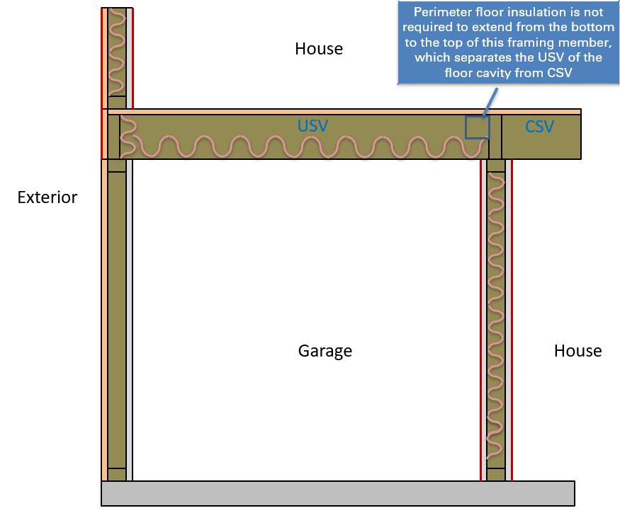

We also agree that improved language is needed in this section and will include those revisions in the 2022 update to ANSI 301.

