**Interpretation:** Permit use of brake horsepower to model VFD ventilation fan power

**Designation:** IR 301-2022-007 (Carry Forward 301-2019-037)

**Approved:** March 3, 2025 by RESNET SDC 300

**Effective Date:** April 3, 2025

**Reference:**

Standard _____ ANSI / RESNET / ICC 301-2019 and 301-2022___

Page Number(s): ________________________________________________

Sections(s): 4.2 Energy Rating Reference Home and Rated Home

Configuration, and Normative Appendix B ______ _______

Table(s): Inspection Procedure for Minimum Rated Features _______

Relating to: Building Element: Dwelling Unit Mechanical Ventilation System(s)

**Request from**:

Name: __ Zachary Vergata_________________________ _____ ____

Affiliation: ___Steven Winter Associates, Inc.____________ __ _ ___

Address: ___55 N Water St., Suite 1 ______________________________

City: __Norwalk_______ State: ______CT________ Zip: _____06854___

Email: ___zvergata@swinter.com_______________________________________

**Background Statement:** *Provided by person requesting the interpretation.*

VFD fan motors may be rated in both brake horsepower and horsepower. Horsepower will represent the sizing of the motor and brake horsepower will represent the power at a set speed and/or design condition. Some ventilation fan manufacturers use brake horsepower to present fan power at set specific CFMs for their VFD controlled units. This applies to singular fans, such as a central rooftop exhaust fan, and combo units, such as an ERV with a supply and exhaust fan. For example, below, Figure 1 shows a Greenheck rooftop exhaust fan with brake horsepower listed at specific static pressure conditions and CFM settings, and Figure 2 shows a Renewaire central ERV with brake horsepower listed at specific static pressure conditions and CFM settings.

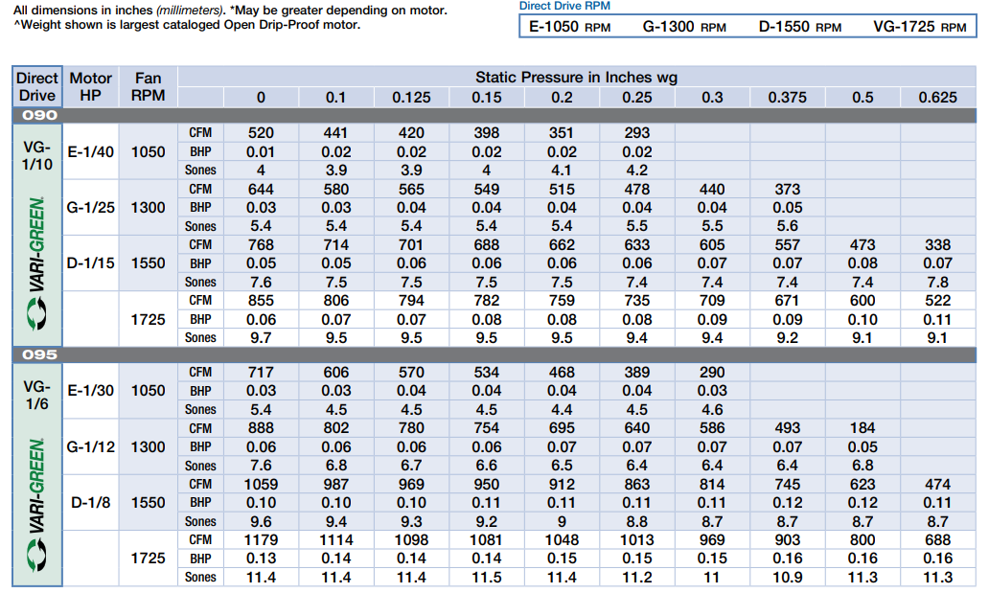

*Figure 1 – Greenheck G-090-VG (exhaust fan) air flow performance chart*

*Figure 2 – Renewaire HE2XRT (ERV) air flow performance chart*

Currently, section 4.2.2 of ANSI/RESNET/ICC 301 permits fan motor power to be calculated using only horsepower. This presents an issue when modeling VFD ventilation fans whom’ s design conditions, static pressure and set RPM, result in an operational brake horsepower lower than the motor horsepower. As currently written, ANSI/RESNET/ICC 301 would force that fan power be calculated using the motor size or horsepower. This results in overestimating the power consumption of VFD controlled ventilation equipment, since the horsepower rating of the motor may be significantly higher than installed power, depending on design conditions. Below, Figures 3 and 4 illustrate a 47.6% difference between system Watts/CFM when using horsepower or brake horsepower to calculate fan power.



*Figure 3 - ERV Schedule showing HP vs. BHP*

|  |  |  |  |  |
| --- | --- | --- | --- | --- |
| **Unit** | **Total Watts using HP** | **Total W/CFM using HP** | **Total Watts using BHP** | **Total W/CFM using BHP** |
| Renewaire  HE-2XJRTV-S35W | 4590.8 | 1.3 | 2926.6 | 0.8 |

*Figure 4 – Calculated Watt/CFM of Figure 3 ERV*

Section G3.2.2.8 of ASHRAE 90.1-2022 provides equations for converting brake horsepower to watts. See Figure 5 for reference. Functionally, it is the same equation that ANSI/RESNET/ICC 301 lists in Section 4.2.2 Normative Note 4, “Fan motors rated in horsepower shall be converted to Watts by multiplying by 746 and dividing by fan motor efficiency”, but with brake horsepower substituted for horsepower.

*Figure 5 – ASHRAE 90.1-2022 System fan power calculation equations*

**Proposed Interpretation:** *Provided by person requesting the interpretation.*

For fans with manufacturer published brake horsepower at predefined fan speeds, the brake horsepower that most closely matches the total system ventilation rate can be permitted to be used to calculate equipment power. It can be converted to Watts by multiplying brake horsepower by 746 and dividing by fan motor efficiency.

**SDC Response:**

Is the proposed interpretation correct? _____ Yes __X___ No

**SDC Comments:**

Within [Table 4.2.2(1) of ANSI/RESNET/ICC 301-2022](https://codes.iccsafe.org/content/RESNET3012022P1/chapter-4-energy-rating-calculation-procedures#RESNET3012022P1_Ch04_Sec4.2.2), table note ‘m’ and ‘n’ elaborate on the available options to determine “Dwelling Unit Mechanical Ventilation System fan power” for the Rated Home.

Where the DUMV system serves multiple dwelling units, note ‘n’ offers a default of 1 Watt/cfm where fan power cannot be determined and Normative Note 4 offers the following alternative calculation for fan power:

“4. (Normative Note) Fan motors rated in horsepower shall be converted to Watts by multiplying by 746 and dividing by fan motor efficiency. Where fan motor efficiency is unknown, use 0.65 for single-phase and 0.75 for 3-phase motors.”

While it is understood that other modeling protocols like ASHRAE 90.1 Appendix G use this same equation with “brake” horsepower rather than “horsepower”, a proposed change to Standard 301 via an Addendum would be required to specifically accommodate the use of “brake” horsepower.

The current intent of the Standard is to use horsepower (HP) to convert to Watts, or use the other available W/cfm defaults, or determine fan power by “observation” via direct measurement of Watts, as allowed by Section 4.5.1.