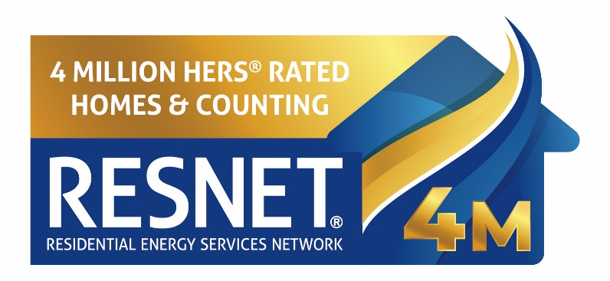

(Rating Company/Provider) Joins RESNET® to Mark the Milestone of Over 4 Million Homes in the U.S. Being HERS® Energy Rated
(CITY, STATE) – DATE (Rating Company/Provider) joins the Residential Energy Services Network (RESNET) in celebrating the meeting the threshold of over four million homes in the United States energy rated with a HERS Index Score. The HERS Index Score is the U.S. standard for measuring a home’s energy efficiency.
Like the miles-per-gallon calculation for cars, a HERS Index Score allows for a uniform estimate of a home’s energy consumption and provides buyers/owners with a reference point for how energy efficient it is as compared to other homes. Heating, cooling, and water heating constitute the largest cost of homeownership outside of the mortgage loan, and the HERS Index Score can help homeowners outline the energy features of the home and the expected cost of utility bills.
The HERS Index Score plays an increasingly important role in the housing industry, used by builders, utilities, real estate professionals, and government agencies to measure the efficiency of their homes, as rated by certified RESNET Home Energy Professionals.
Sample quote from company/provider representative: “We at (Company/Provider) are very proud of this milestone and to be a part of the thousands of professionals who rate HERS homes every day, helping prospective and current homeowners live in the most comfortable, energy efficient homes as possible.”
Says RESNET Executive Director Steve Baden, “What started in 1995 with just a few hundred homes rated per year, has now grown exponentially, backed by consumer demand. By 2012, there were more than one million homes HERS rated, another million homes by 2017, another million in 2021, and now the milestone of another million home HERS rated, a little over three years later. The upward trajectory of home buyers choosing more energy efficient, comfortable, and healthier homes is certain to continue.”
The four million HERS-rated homes:
• Reduced carbon dioxide emissions by over 74 million tons (the equivalent of taking nearly 15 million passenger vehicles off the road for one year)
• Improved the health and comfort of more than 16 million residents
• Saved homeowners over $12 billion in energy costs
In 2023, over 360,000 homes were HERS-rated, with over 28 percent of new single-family homes built receiving a HERS Index Score.
RESNET will commemorate this milestone throughout the year, recognizing the RESNET certified raters, inspectors, and contractors across the country who helped to reach this milestone.
For more information, visit www.resnet.us
Company/Provider boilerplate and contact information here.

