SDC 1100 Meeting
July 29, 2025; 2-3 pm EST
Via Microsoft Teams
Click link to join
Meeting ID: 213 433 394 960 9
Passcode: QV3G4ab2

AGENDA
- Call to Order (Jacob Atalla, Chair)
- Roll Call (Ryan Meres)
- Consideration of new members for the SDC 1100 Task Group
- Formation of a new HERS H2O Implementation Standards Task Group
- Update on the work of the SDC 1100 Task Group
- Revisions to the HERS H2O Implementation Guidelines
- Appendix for using HERS H2O as an efficiency/incentive program
- New business

Alternative Water Sources Discussion
Current PDS-01/02 Language for Gray Water:
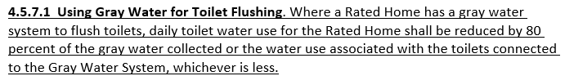

Rainwater capture has been discussed in the past, but no formal action taken.

Suggestions for rainwater data fields:
- Roof size (collection area)
- Storage size (cistern)
- Rainfall (monthly, annual, seasonal?)
  - Do we need a data source or is it up to the system designer?
  - TMY data
- End use (potable, irrigation, toilets)
- Growing season (NOAA/ATLAS weather data)
  - May need changes to irrigation calcs too

Rainwater catchment system standards: ICC-805 and ARCSA/ASPE/ANSI 63.

Type of Alternative Water |  | Offset Calculation
Source | Use | Source | Effective Yield | Offset
Gray water collected from plumbing products and appliances | Flushing toilets | Calculated as the sum of all end-use sources (e.g., showers, lavatory faucets, clothes washers) for the rated home. If not all potential sources of a similar fixture type feed the system, the water for that end use should be equally divided across the number of fixture types present in the Rated Home (e.g., if one of two showers are connected to the gray water system, only half of daily shower water use would be eligible to be counted as gray water) | 80% | Total of source times the effective yield, applied to (but not to exceed toilet_{gpd})
Rainwater collected from the lot area | Irrigation  (Could consider indoor uses) | Calculated as the sum, in gallons from all rainwater collection surfaces, not to exceed the rainwater storage capacity.  Square feet collection area X Annual rainfall in inches X 0.6 (conversion factor) | 80% | Gallons of rainwater collected times the effective yield, not to exceed annual outdoor water use, determined by Section 4.6.1.
R.O.
Condensate
Gray Water | Irrigation

