RESNET® SDC 200 Meeting
Monday, August 10, 2026
10:00 AM – 11:00 AM ET
MEETING RECORDING

Members & Staff | Present | Absent | Other Attendees
Members  Doug McCleery  Eurihea Speciale  Jesse Krivolavek  Mark Schroer  Mary English  Olga Cano  Robert Cantrell  Robert Lipkins  Rod Buchalter  Sharla Riead  Tei Kucharski  Zak Shadid | Members  Eurihea Speciale  Jesse Krivolavek  Mark Schroer  Mary English  Tei Kucharski  RESNET STAFF  Noah Kibbe  Laurel Elam  Rick Dixon | Doug McCleery  Olga Cano  Robert Cantrell  Robert Lipkins  Rod Buchalter  Sharla Riead  Zak Shadid | Laura Duke  Tyler Ashworth

Meeting began at 10:04 a.m. Eastern Time.

The members approved the last meeting minutes.

- NWI HERS-2013-106 Clarification of the 15-month timeframe for Rater Certification - SDC200 Voting closed on Monday, July 27th; what was the result? Any comments received?
  - Voting closed on July 27th for NWI HERS-2013-106, Clarification of the 15-month timeframe for Rater Certification - SDC200. The vote passed. Eurihea Speciale confirmed with RESNET staff that there were no group member comments.
  - It was sent out for public comment, opened on August 5, 2026, and closes on September 4, 2026.
- Potential Chapter 2 impacts from SDC200/900 Work Group
  - The SDC200/900 Work Group has been tasked with “cleaning up the language” between Chapter 1, 2, and 9. This group is ensuring there is no conflicting language throughout the chapters and/or identifying impacts on each of the chapters.
  - It is a time-intensive and big task for the working group. The group is meeting twice a month and has the framework set for the group to clean up language.
  - Members noted that work extending beyond the current new work item may require SMB approval. Rick Dixon was invited to the next joint working-group meeting to review the scope and determine whether additional authorization is needed.
- Work Item Suggestion - Section 207 Review and possible expansion, we had an action item to take a look at this for discussion during this meeting - This was Eurihea's comment:
  - While reviewing Section 207 of the standards, I realized this section may need to be reviewed and updated. It doesn’t appear to consider all the possible ways that someone could have had a lapse in certification or have been revoked and seems to be specific to raters who have either not met their PDH requirements or had disciplinary problems, but not someone who didn’t meet the 3 year rating submittal requirement, etc. In any case, it also appears to be very punitive and lean more towards someone with disciplinary issues. I’d like to request that we create a new work item to review the standards, discuss the intent, compare all the ways you can have your certification revoked, and determine whether or not the existing language adequately addresses all of them in a reasonable manner.
  - In reference to Section 207, the members described experienced Raters losing certifications. The members provided examples that can produce a lapse in certification, such as job changes, taking leave from the industry, or loss of Provider status.
  - Members agreed the language is too punitive and does not address exceptions in certain situations.
  - Members acknowledged that Raters need to maintain their certifications, while Providers and RESNET could assist with notifications and record maintenance.
  - Members brainstormed more consistent notifications/communication, a non-disciplinary lapse, or an alternative reactivation option.
  - Action Item: RESNET Staff will request that Sharla Riead add the working version of Chapter 2 to SharePoint.
  - Eurihea noted discussing the possibility of read-only registry access for Raters to update their contact information and view their credentials.
  - No changes were made to Section 207. The committee agreed to discuss at next meeting.
- Clean up has also been requested for confusing language in the standards from the 7/1/26 requirements from a few Providers, one such comment is below. Rick, do we need to submit a new NWI request for the ability to add clarifying language and make editorial updates as needed? It seems section 207 does need some work.
  - What are the current energy modeling PD requirements for HERS Raters? Previously they just needed to take a course on the software they work in.
  - From the current language I can't tell if they just need to take any course that meets any of the requirements of 207.1.2.2-207.1.2.5 or if they need to meet all of those requirements. I think it's meant to read as all, but want to be sure.
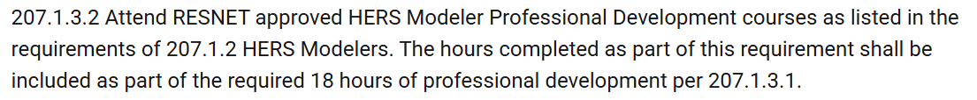
  - If it's the former, any, then that would essentially eliminate the requirement to do energy modeling training because they could just meet 207.1.2.4 like they usually would. And if it's the latter, all, it seems like 207.1.2.3.1 and 207.1.2.3.2 require courses that are specifically approved as HERS Modeler Professional Development courses, but might not be Rater Approved PDU training courses. Is there a list maintained of the HERS Modeler Professional Development courses that are approved?

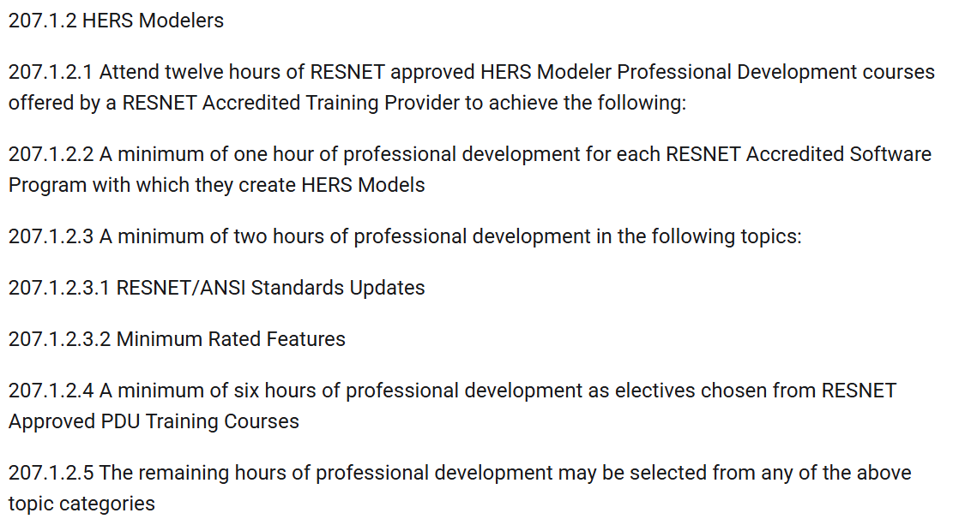
  - The discussion on 207.1.2.2-207.1.2.5 was tabled for the next meeting.
- Other Business:
  - Status of Exam Working Group: Laurel and Tei
  - Status of Registry updates for SDC200 items that became mandatory on 7/1/26: Laurel
  - Question about how Professional Development courses will be distinguished from each other now that minimum hours in specific categories are required: Scott or Laurel
  - Other business was tabled for the next meeting.
- Anything Else?
- Wrap Up - Action Item Review
  - Action Item: RESNET Staff will request that Sharla Riead add the working version of Chapter 2 to SharePoint.
Meeting adjourned at 11:04 a.m. Eastern Time.

