RESNET SDC 200 Training TG Meeting
May 13th, 2025
Second & Fourth Tuesdays of the Month
11:00 AM – 12:00 PM ET
MEETING RECORDING
Passcode: 9?vzE.V#
Present: Doug McCleery, Sharla Riead, Tei Kucharski, Mary English, Zak Shadid, Robert DuTeau
Staff: Noah Kibbe, Katie Stewart
Meeting began at 11:04 AM ET.
Review and Breakdown of Scope
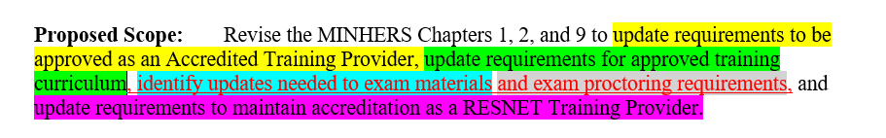
Doug McCleery provided a breakdown of the Task Group’s scope. Each color represents a specific scope item.
The Task Group will ask the following to RESNET staff: What is the scope for which the Task Group can suggest updates, can they receive access to exam questions and materials, and what is the process for maintaining the confidentiality of exam materials?
- Exam Materials & Scope
  - Exam questions are confidential; Doug raised the issue of limited access and influence.
  - RESNET and the psychometrician will need to advise on next steps.
  - Noah Kibbe will connect Doug with Rick Dixon for clarification on the scope of updates to exam materials.
- Approved Training & Curriculum: Approved training may become a standalone category within the curriculum.
- RFI & Accreditation
  - The RFI group is reviewing accreditation needs, including possible additional exams/training.
  - Some exam content is still based on outdated 2014 standards. This needs to be addressed systemwide.
- Proctoring Updates
  - Transition: Robert Lipkins is retiring; a transition period is in place.
  - Key Points:
    - Concerns raised about AI use during exams; AI may need to be disabled explicitly.
    - Create a list of approved websites and restrict searches during exams.
    - A proctoring tool that restricts AI access was shared with Sharla; further research needed.
    - Action: Sharla to forward proctoring info to Robert Lipkins, and Tei to research AI restrictions.
- Volunteer Team Assignments and Structure
  - Exam Materials: Sharla Riead, Tei Kucharski, and Doug McCleery.
  - Training Curriculum: Mary English, Sharla Riead, and Eurihea Speciale.
  - Proctoring: Robert DuTeau, Tei Kucharski, and Sharla Riead.
  - Maintaining Accreditation: Robert DuTeau, Doug McCleery, Eurihea Speciale, and Zak Shadid.
  - Training Provider Requirements: Eurihea Speciale, Zak Shadid, Doug McCleery, and Robert DuTeau.
Open Questions
- AI Use in Exams: Can AI features be reliably disabled? What is enforceable?
- Exam Access: What access/influence do committees have over confidential exam questions?
- Multiple Provider Language: Doug to review relevant standard sections and propose updates at the next meeting.
- Test Differentiation: Consider separate tests for Trainers and Quality Assurance Designees (QAD), as with the more robust HERS Rater test.
Timeline and Planning
- Standards Update Deadlines: Go into effect (phase one) July 1st, 2025, and (phase two) January 1st, 2026 (phased 6-month rollout).
- No strict deadline for completion, but the 2025–2026 timeframe is the working goal.
- Next Steps: Organize working groups, initiate contact with RESNET on exam question oversight, finalize AI proctoring options.

Meeting ended at 11:43 AM ET

