Comment/Explanation*:
Include your justification for your proposed change to the draft standard below.
_________________________________________________________________________________________
The UEF metrics are the result of a 24-hr simulated-use test and incorporate “recovery efficiency” (η_{r}), which is near steady-state, and a “standby loss coefficient” (UA). The COP_{COMP} calculation does not appear to accurately convert UEF to COP.
Recovery efficiency is reported to DOE and is found in the first draw cluster of the test. The water heater performs a very large draw intended to force the unit under test to cut-in and undergo a long recovery. During this recovery, the efficiency of heating water is calculated. We say “near steady-state” as this calculation includes the start and end of the recovery where the HP won’t be operating at full efficiency. The actual steady-state COP will be slightly higher than the recovery efficiency. However, as shown in the chart below which plots the models in the DOE’s CCMS database, the actual recovery efficiency is lower than the calculated COP_{COMP}.
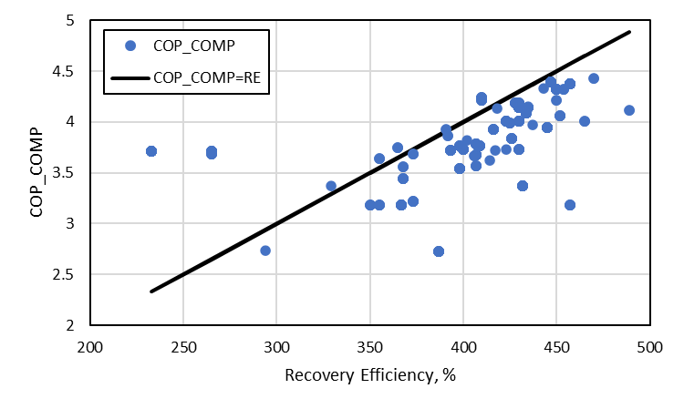
We have concerns about how this modelling corresponds with reality. It appears that ranges are provided and if the rating software produces results within the range, then the software is “verified.” How are these ranges created?

Proposed Change to the Draft Standard*
Use “strikethrough” and “underline” formatting to indicate all proposed changes. Changes must be shown with “hard-formatting” strikethrough and underline, not “track changes”.
Use a color other than red to indicate proposed changes to the draft.
____________________________________________________________________________________________
v.3 For all HPWH, the UEF shall be separated into the heat pump compressor COP shall be the recovery efficiency and the tank UA shall be found according to Tables X and Y.
Table X: HPWH Compressor COP Values
First Hour Rating (gal/hr) | COP_{comp}
>= 18, < 51 | 1.0005 * UEF - 0.0789
>= 51, < 75 | 1.0909 * UEF - 0.0868
>= 75 | 1.1022 * UEF - 0.0877

Table Y: HPWH Tank UA Values
Tank Volume (gal) | Tank UA (Btu/hr-F)
<= 58 | 3.6
> 58, <= 73 | 4.0
> 73 | 4.7

(Informative Note) There are no HPWH products currently on the market with First Hour Rating < 18 gal/hr.

