COMMENT 6 (only if comment 5 is rejected)
…
Table 5.4.1 Minimum Assessed Products
Building Element | Minimum Assessed Products
Foundations,  Subgrade Enclosures,  and Slabs-on-Grade | Concrete elements, incl. walls, footings, pads, piers & piles
Foundations,  Subgrade Enclosures,  and Slabs-on-Grade | Reinforcement bars and mesh
Foundations,  Subgrade Enclosures,  and Slabs-on-Grade | Perimeter frame walls integral to foundation assembly
Foundations,  Subgrade Enclosures,  and Slabs-on-Grade | Insulation, exterior & interior
Foundations,  Subgrade Enclosures,  and Slabs-on-Grade | Barriers (air tightness, waterproofing, drainage)
Foundations,  Subgrade Enclosures,  and Slabs-on-Grade | Aggregate
Exterior Walls | Wall structure (framing, SIP, masonry, other)
Exterior Walls | Sheathing
Exterior Walls | Strapping/furring
Exterior Walls | Cladding
Exterior Walls | Windows
Exterior Walls | Exterior doors (glazed and opaque)
Exterior Walls | Insulation (cavity, continuous, band joist, other)
Exterior Walls | Barriers (air tightness, waterproofing)
Exterior Walls | Paint (if site painting required)
Roofs | Roof structure (framing, SIP, other)
Roofs | Roof deck sheathing
Roofs | Roof deck strapping
Roofs | Roofing
Roofs | Insulation
Roofs | Barriers
Roofs | Skylights
Interior Construction | Floor structure (framing, SIP, other)
Interior Construction | Floor sheathing/subflooring
Interior Construction | Walls (framing, masonry, other)
Interior Construction | Ceiling structure (framing, SIP, other)
Interior Construction | Structural posts and beams
Interior Construction | Insulation used exclusively for sSound and/or fire insulation
Interior Construction | Doors
Interior Construction | Party walls
Interior Construction | Stairs
Interior Construction | Shafts
Interior Finishes | Wall finish
Interior Finishes | Ceiling finish
Interior Finishes | Flooring
Interior Finishes | Paint
Plumbing | Supply and drain piping
Plumbing | Fixtures (toilets, sinks, tub/shower)
Plumbing | Hot water equipment
HVAC | Heating & cooling equipment
HVAC | Mechanical ventilation systems
HVAC | Distribution systems (ducts, tubing)
Electrical | Wire, boxes, panels
Attached and Detached Garages, excluding accessory dwelling units and all other attached or detached buildings | Assessments of attached and detached garages shall include all Minimum Assessed Products included in this table used to construct the garage.
Balconies, decks and porches, excluding those not attached to the assessed dwelling unit | Assessments of attached balconies, decks and porches shall include all Minimum Assessed Products included in this table used to construct the balconies, decks and or/porches.

Table 10.4.1 Excluded Building Components
Building Element | EXCLUDED Building Components
Foundations, Subgrade Enclosures, and Slabs-on-Grade | Formwork
Foundations, Subgrade Enclosures, and Slabs-on-Grade | Ties
Foundations, Subgrade Enclosures, and Slabs-on-Grade | Fasteners
Foundations, Subgrade Enclosures, and Slabs-on-Grade | Sub slab drainage pipes
 | Insulation
Exterior Walls | Fasteners
Exterior Walls | Insulation around window and door units
Exterior Walls | Trim and flashing
Exterior Walls | Exterior shading
Exterior Walls | Insulation and sealants around glazing units
Roof | Fasteners
Roof | Gutters
Roof | Downspouts
Roof | Fascia
Roof | Soffit
Roof | Trim and flashing
Roof | Insulation
Interior Construction | Fasteners
Interior Construction | Sound proofing sealant and gaskets
Interior Construction | Door hardware
Interior Construction | Trim
Interior Finishes | Fasteners
Interior Finishes | Cabinetry
Interior Finishes | Counters
Interior Finishes | Hardware
Interior Finishes | Trim
Plumbing | Taps
Plumbing | Valves
Plumbing | Fittings
Plumbing | Controls
HVAC | Controls
HVAC | Wire
HVAC | Hardware
HVAC | Mounts/supports
 | Refrigerants^{(a)}
Electrical | Hardware
Electrical | Finishes
Electrical | Light fixtures
Electrical | Panels
Electrical | Solar/PV systems^{(a)}
Accessory Structures | ADUs, sheds, storage units, ramps and other detached structures
Communications | All components
Electronic Safety and Security | All components
Integrated Automation | All components
Fire suppression | All components
Equipment & Furnishings | All components
Special Construction & Demolition | Special Construction
Special Construction & Demolition | Facility Remediation
Special Construction & Demolition | Demolition
Sitework & Landscape | Site preparation
Sitework & Landscape | Site improvements (hardscape, softscape)
Sitework & Landscape | Liquid and Gas Site Utilities
Sitework & Landscape | Electrical site improvements
Sitework & Landscape | Site communications
Sitework & Landscape | Misc. site construction
- Not excluded where optionally included in accordance with Section 6.3.

10.6 Sample Report for Confirmed Assessment for a Single Detached Dwelling Unit (Informative)

Delete insulation from the example reporting tables consistent with above changes.

REASON: This comment is provided as an alternative to the proponent’s preferred comment #5. If comment #5 is accepted this comment will be withdrawn by the proponent.

Counting the full embodied carbon impact of all insulation in this standard while neglecting the material’s primary purpose of operational energy and emissions savings (while at best separately addressing operational emissions in an relative index such as RESNET 301 CO2 Index) is not an adequate or consistent characterization of the total carbon profile of insulation materials -- considering both their total embodied carbon (as done in this standard) and their total operational emissions benefit. The separate use of the RESNET 301 standard’s CO2 Index doesn’t work toward this purpose because it is a relative index (uses a reference baseline) resulting in only a partial assessment of the impact of the full insulation amount in a building while RESNET 1550 counts the full impact of the insulation’s embodied carbon. In other words, the inconsistency in treatment of insulation between the two standards eliminates the ability to look at insulation from a total carbon perspective and its full impact in both categories of emissions: embodied and operational. Deleting insulation from the minimum assessment table and including it in the excluded (or optional) assessment table will avoid this inconsistency.

Furthermore, deleting insulation from the table of minimum assessed products is consistent with its relevance as a GHG emission reduction solution, not a liability when viewed completely from a total carbon perspective at a big picture level. For example, the U.S. insulation industry’s total annual embodied emissions is more than an order of magnitude less than any one of the top 3 “heavy hitter” building and construction materials that collectively account for almost 2/3rds of all U.S. building and construction material emissions (see Figure and Table below). Consequently, this proposal approach is consistent with the EPA’s key category analysis of US emission sources coupled with an application of the 80/20 rule as reasonable basis for policy and standard development (e.g., get 80 percent of the problem solved with 20 percent of the effort and cost). This approach, particularly if extended beyond just the insulation focus of this comment (which is one of the more obvious applications), would also serve to dramatically simplify the scope of the standard and its application by practitioners without sacrificing the goal of the standard to effectively reduce embodied emissions with meaningful climate impact for the level of effort.

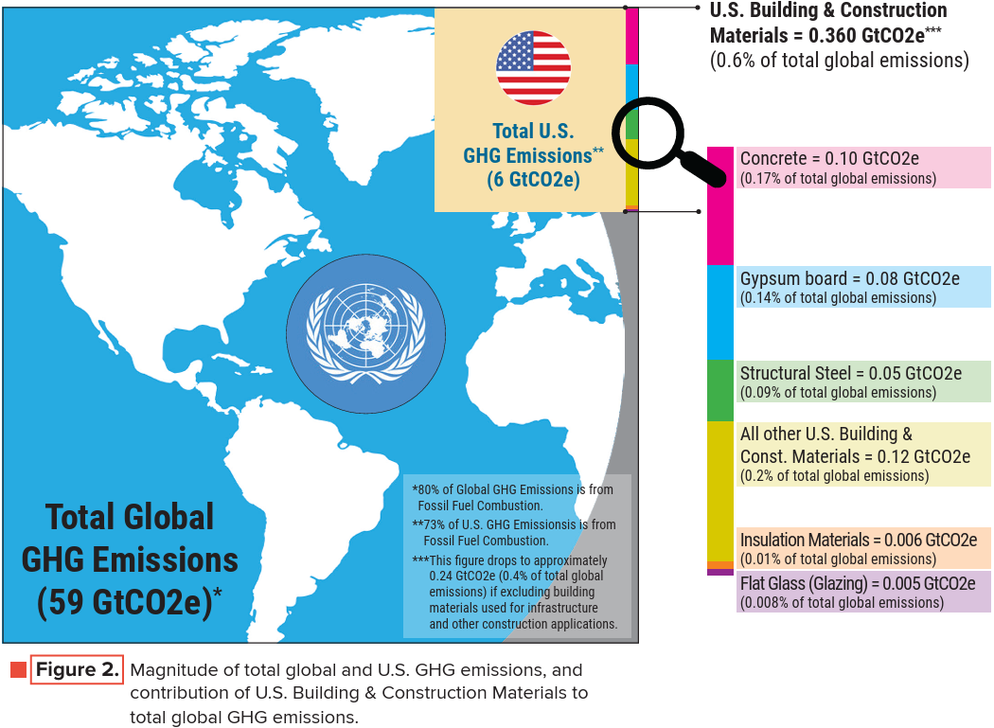
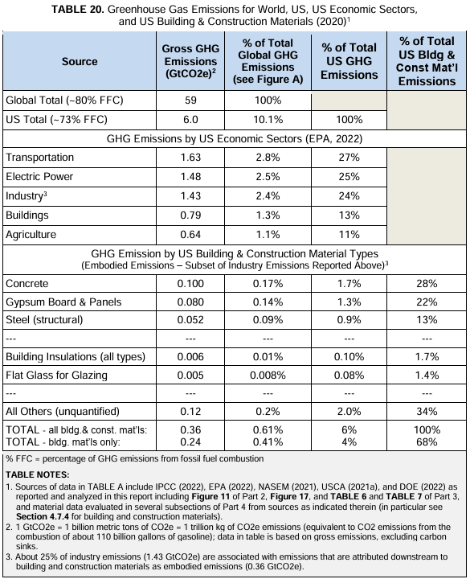
Sources for Figure and Table above:
- https://www.continuousinsulation.org/sites/default/files/uploads/attachments/node/210/ci-factssheetdecarbfinal.pdf
- https://www.appliedbuildingtech.com/content/decarbonization-buildings-review-climate-science-policies-practices-data-and-recommended

In further support and as shown in the Table and Figure above, the entirety of U.S. insulation production in a year accounts for about 0.01% (1/10,000ths) of total annual global emissions yet is used to mitigate nearly 300x that amount per year in annual building stock operational emissions. Insulation also reduces energy demand on both non-renewable and renewable energy sources such that they are used more productively and conservatively – reducing fossil energy demand while allowing available renewable energy resources to cover more of the demand. The above benefits apply to both biogenic and non-biogenic insulation materials and often dwarf any difference in carbon storage or GWP as shown in the Figure below which shows three comparative total carbon profiles for a range of insulation GWPs bracketing current insulation material GWPs (all of which may be considered “low-carbon”).

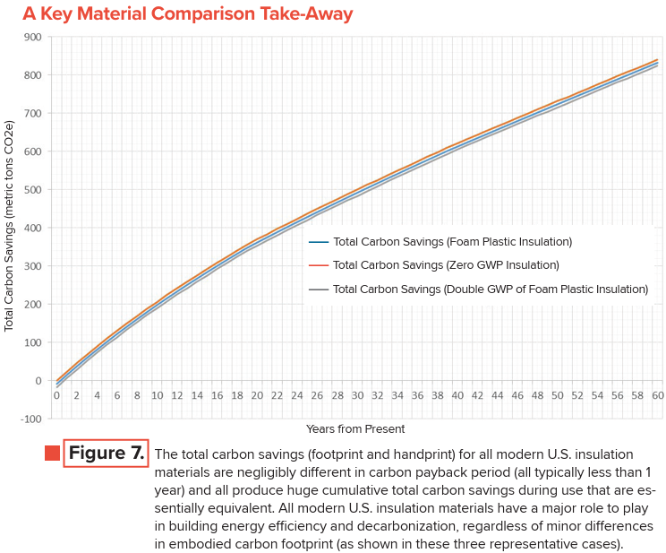
Source:
- https://www.continuousinsulation.org/sites/default/files/uploads/attachments/node/210/ci-factssheetdecarbfinal.pdf

Also, certain insulation materials have multifunctional capabilities that are not addressed in this standard’s siloed focus on embodied emissions which can lead to inadvertent design performance and functional trade-offs for the sake of lowering embodied emissions. This comment assumes that this standard will be eventually used (as intended or as has been already proposed) as a means to meet and enforce embodied carbon benchmarks set elsewhere.

Finally, this proposal is consistent with Table 5.4.1’s current exclusion of (or silence regarding) insulation materials used in floors separating conditioned and unconditioned spaces.

